Royal Cyber Inc.

User Guide

Brightcove custom cartridge for Salesforce Commerce Cloud

Contents

Introduction 2

Multiple Language Support for Business Manager 3

Business Manager Menu for English 4

Business Manager Menu for French 4

Add Video 5

Assign Video(s) 8

Categories/Sub-Categories 8

Master Products 13

Variant Products 17

Standard Products 22

Variation Groups 26

Product Sets 31

Product Bundles 35

Embed Video 39

Bulk Upload 41

Bulk Assign 43

Category 43

Product 45

Storefront Reference Architecture (SFRA) 47

Category (catlanding, searchResultsNoDecorator) 47

Product Page Master / Variant Products(productDetails) 49

Product Page – Standard Products(productDetails) 51

Product Page – Variation Group(productDetails) 52

Product Page – Product Set(setDetails) 54

Product Page – Product Bundle(bundleDetails) 55

SiteGenesis Architecture 56

Category Page (catlanding, categoryproducthits) 56

Product Page - Master/Variant (productcontent, producttopcontent) 58

Product Page - Standard Products (productcontent, producttopcontent) 60

Product Page - Variation Group (productcontent, producttopcontent) 61

Product Page – Product Set (producttopcontentPS) 63

Product Page – Product Bundle (producttopcontentPS) 64

# Introduction

This document provides step-by-step instructions for using Brightcove Salesforce Commerce Cloud Custom Cartridge to upload video files to the Brightcove Cloud/server and publish these files on the storefront (product details page, category landing page, product listing page, etc.) as needed.



# Multiple Language Support for Business Manager

The extension provides multiple UI language support for Busines Manager Interface.

Note: This version of the extension has support for English and French for UI Language.

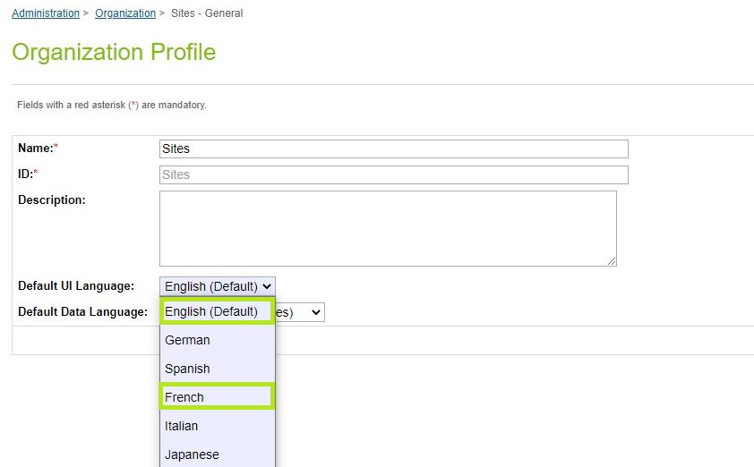

## Business Manager Menu for English

REPLACE CURRENT IMAGES WITH BELOW

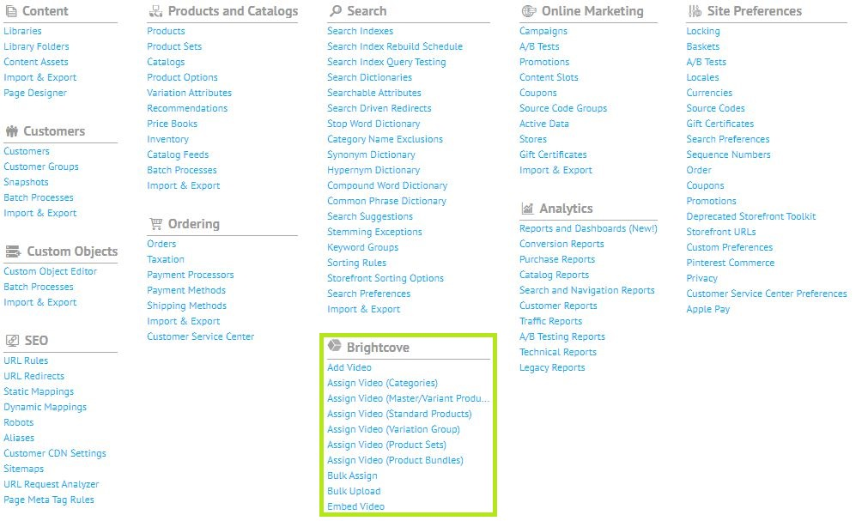

## Business Manager Menu for French

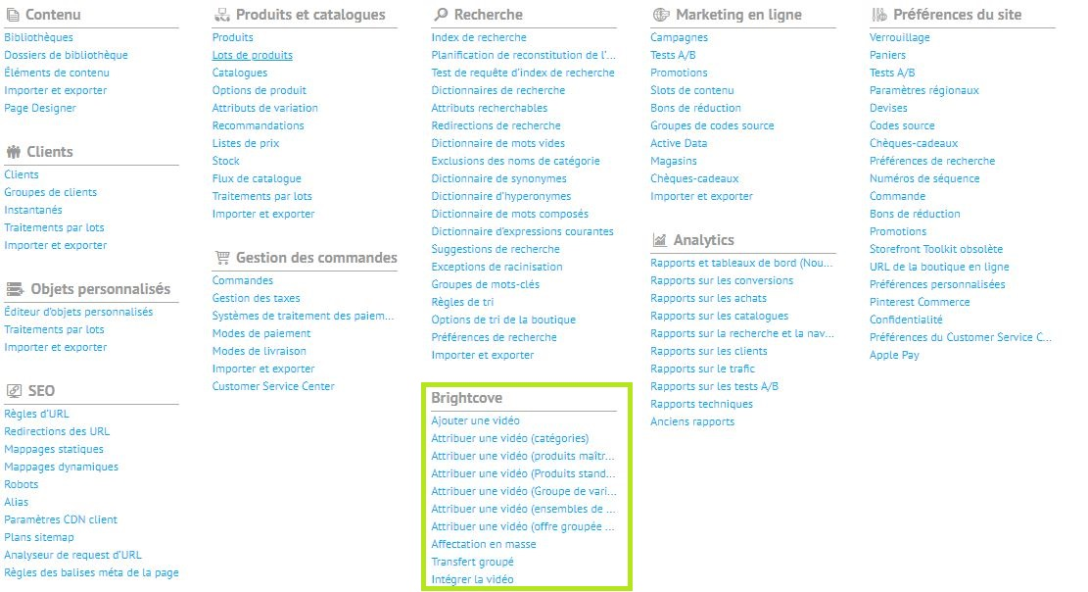

# Add Video

1. Navigate to ***Merchant Tools -> Brightcove -> Add Video***
2. Select data language from the dropdown.

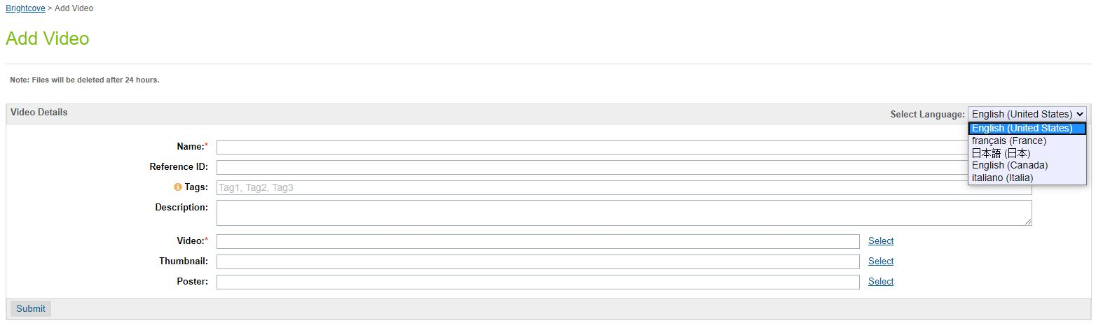

1. Default value will be the default locale selected for the Site.
2. Click the select option next to Video field.
3. Popup will appear, select the video file.

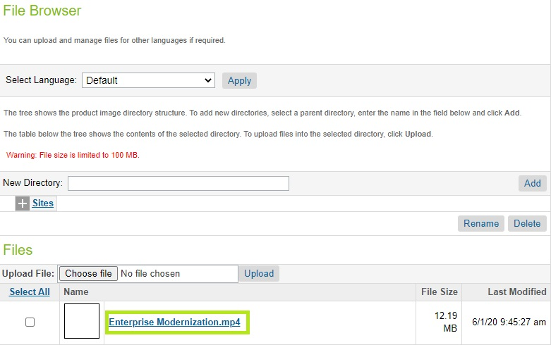

1. Click the select option next to Thumbnail field.
2. Popup will appear, select the Thumbnail file.
3. Click the select option next to Poster field.
4. Popup will appear, select the Poster file.
5. Submit the form to initiate the ingestion process.

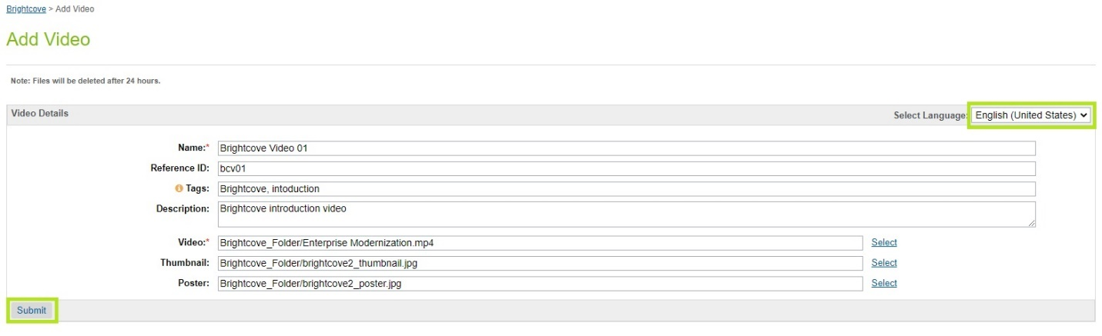

1. Validate the success message on the form after submission.

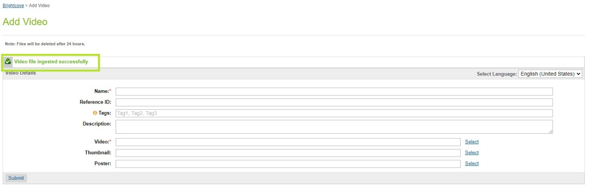

1. Login to Brightcove console and verify the ingested file.

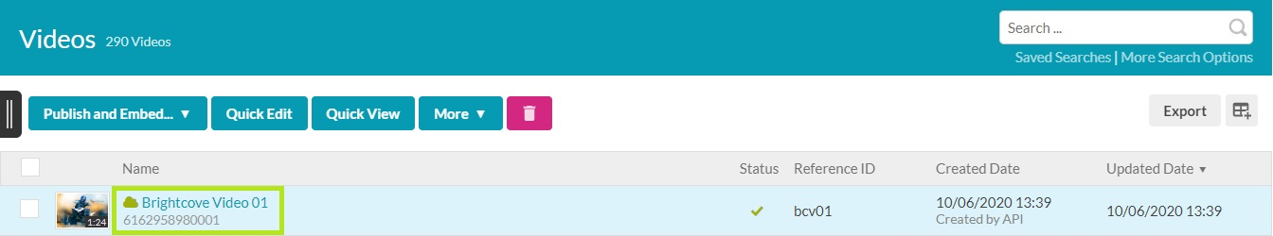

1. Select the ingested video and verify the locale code under the tags section.

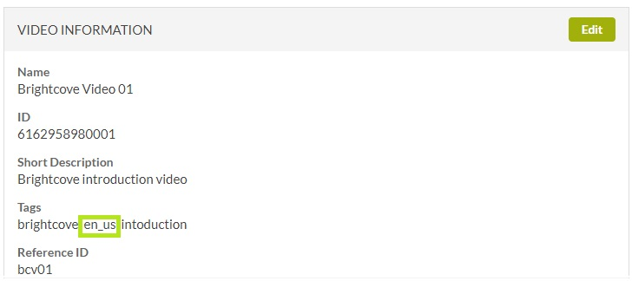

# Assign Video(s)

## Categories/Sub-Categories

***Note: Video(s) will be assigned to the Primary Category and Primary Category video data will render video(s) on storefront.***

1. Navigate to ***Merchant Tools -> Brightcove -> Assign Video (Categories)****.*
2. Video(s) are assigned to locales.
3. Locale related data can be viewed by changing the locale from the dropdown.
   1. English (United States) – en_US

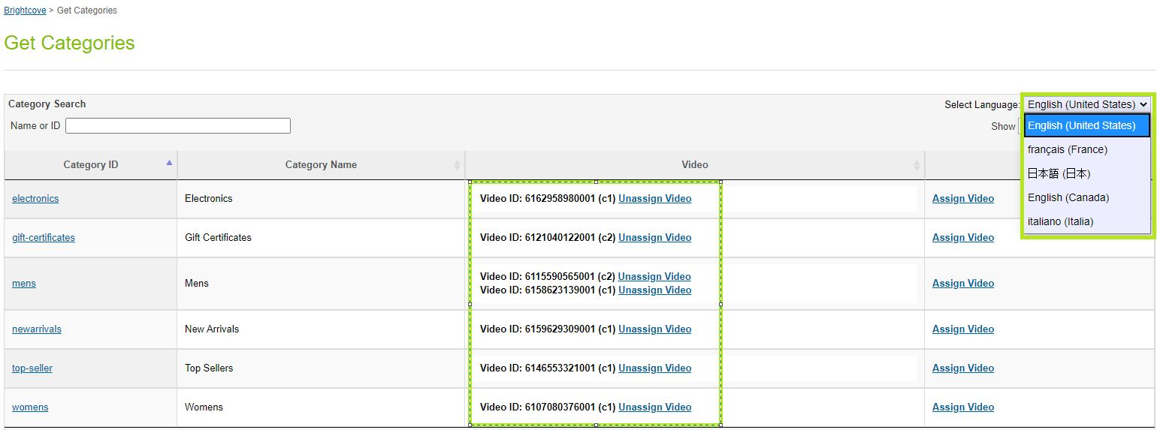

* 1. francias (France) – fr_FR

HERE WE SAY “Note that the only locales currently supported are **English (United States)** and **francais (France)”** THIS IS NOT TRUE, PLEASE REMOVE.

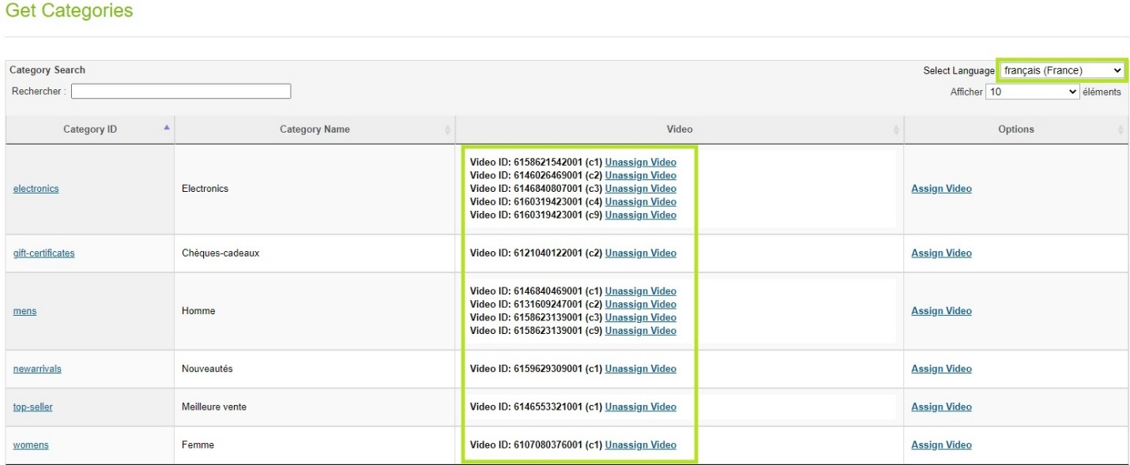

1. Video thumbnail can be viewed by hovering the cursor on ***Video ID***.

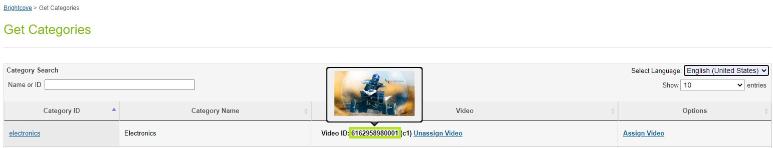

1. Click ***Assign Video*** option to assign video(s).
2. Already assigned video(s) will appear as selected on the assign video(s) grid.

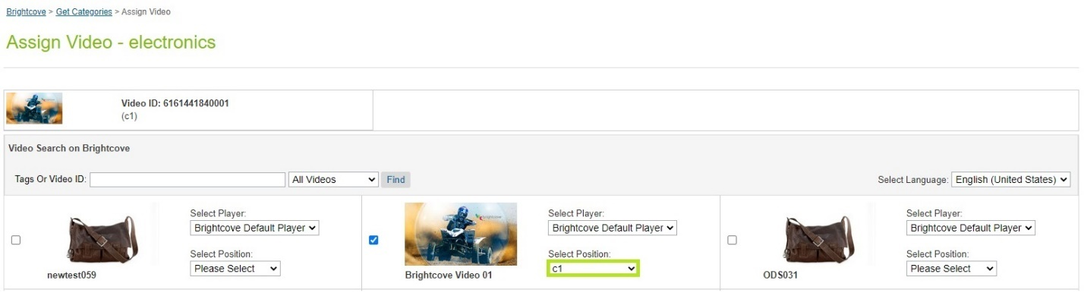

1. Assigned slot cannot be used for the other video(s) for same ***locale***.

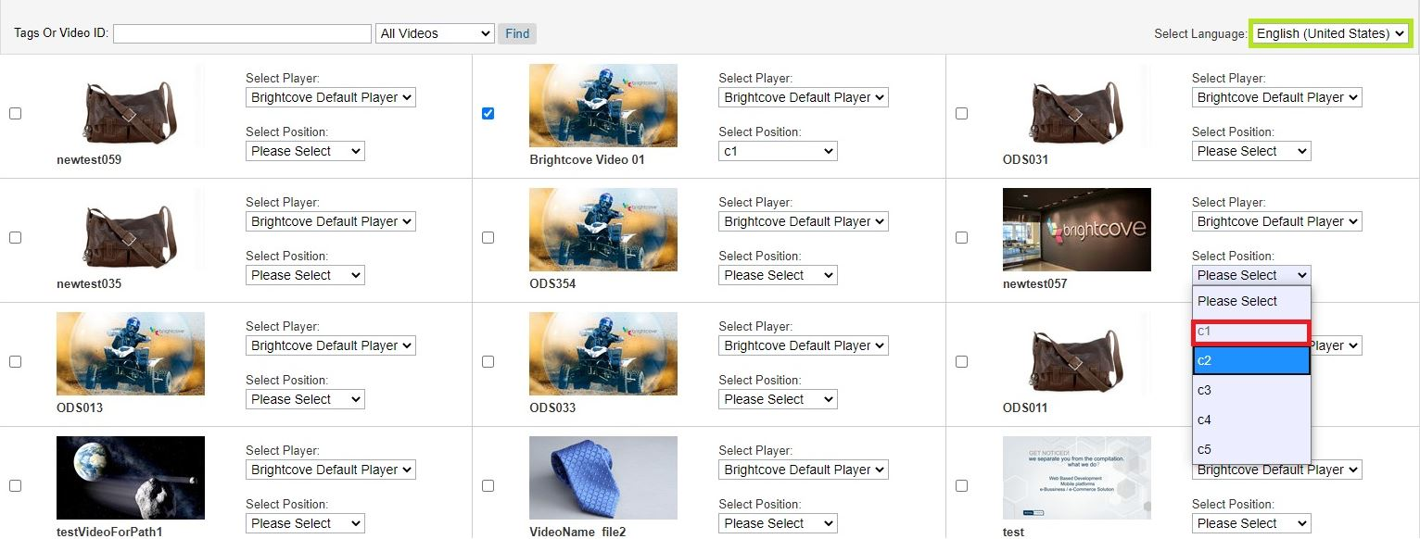

1. Players and slots can be changed by using the respective dropdowns available in each video tile.
2. Select another video with the different slot.
3. Click the Save Video button to assign the selected video(s).

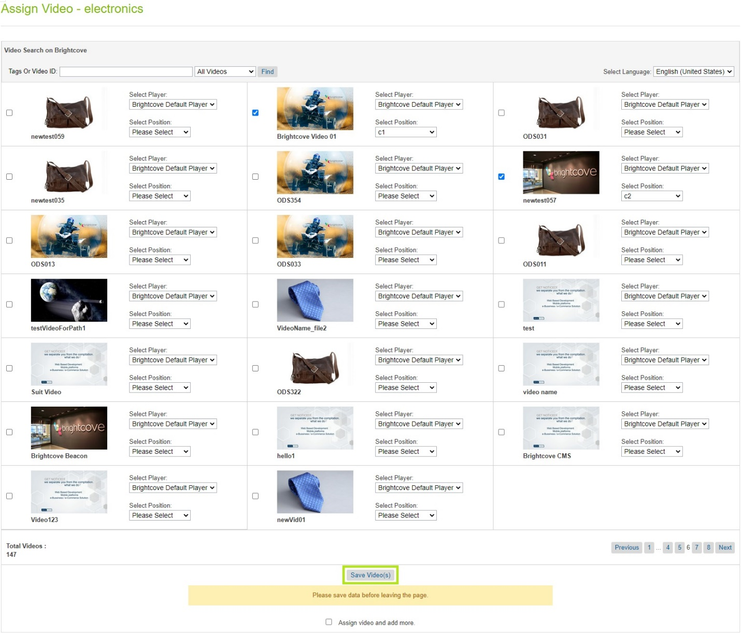

1. Verify the assigned video and the slot.

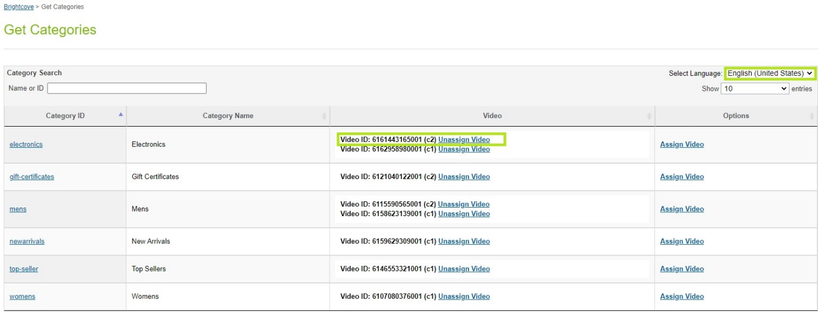

1. Verify the data in category object.
2. Navigate to ***Merchant Tools -> Catalogs***.
3. Select the catalog.
4. Select the category/sub-category.
5. Select ***Edit***.
6. Select ***Category Attributes***.
7. Scroll down to the Brightcove section.

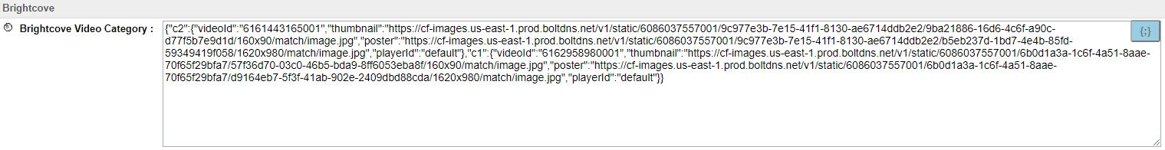

1. To assign video(s) to sub categories, click on the category.

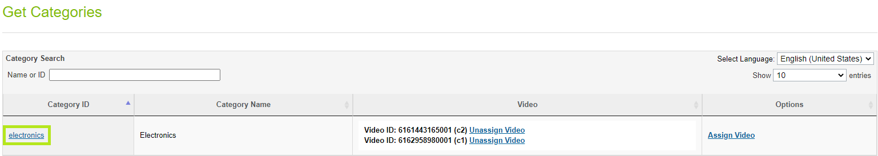

1. Sub categories list will appear.

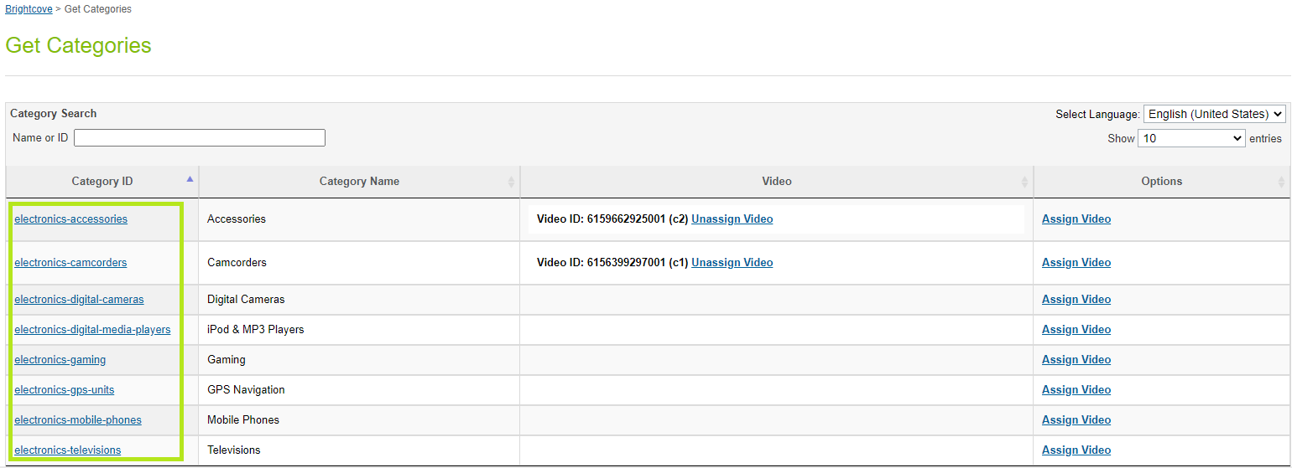

1. Follow the steps from 5 to 18.

## Master Products

1. Navigate to ***Merchant Tools -> Brightcove -> Assign Video (Master/Variant Products)****.*
2. Video(s) are assigned to locales.
3. Locale related data can be viewed by changing the locale from the dropdown.
   1. English (United States) – en_US

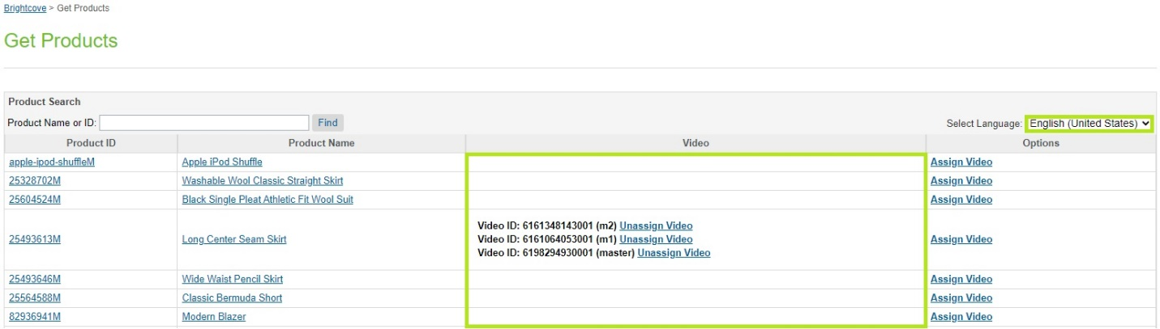

* 1. francias (France) – fr_FR  
     HERE WE SAY “Note that the only locales currently supported are **English (United States)** and **francais (France)”** THIS IS NOT TRUE, PLEASE REMOVE.

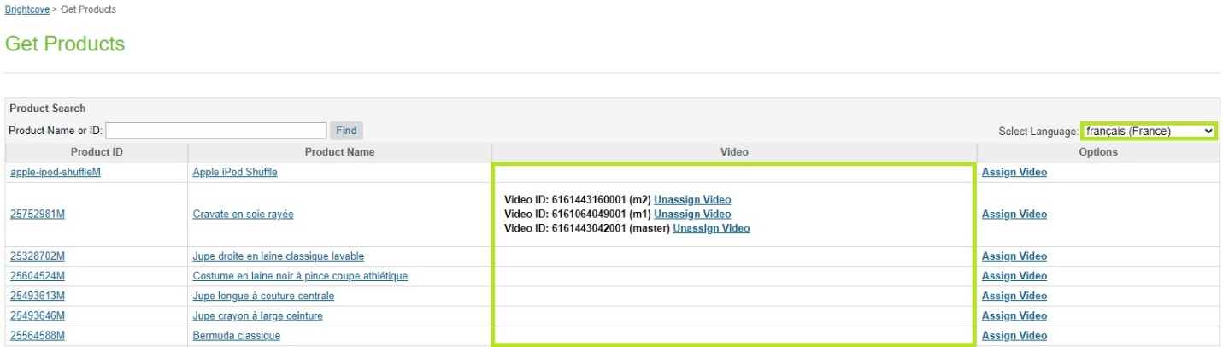

1. Video thumbnail can be viewed by hovering the cursor on ***Video ID***.

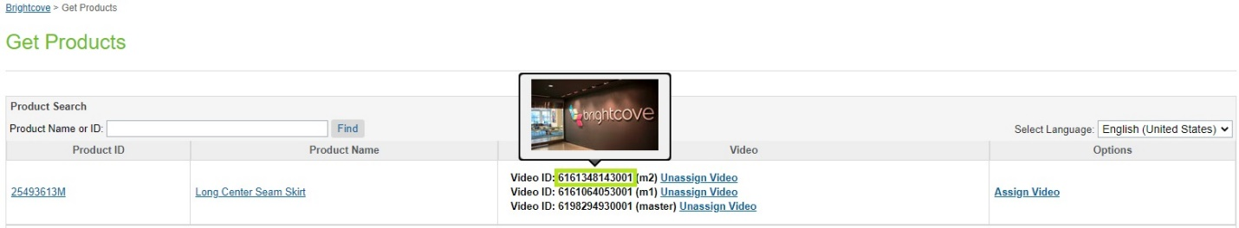

1. Click ***Assign Video*** option to assign video(s).
2. Already assigned video(s) will appear as selected on the assign video(s) grid.

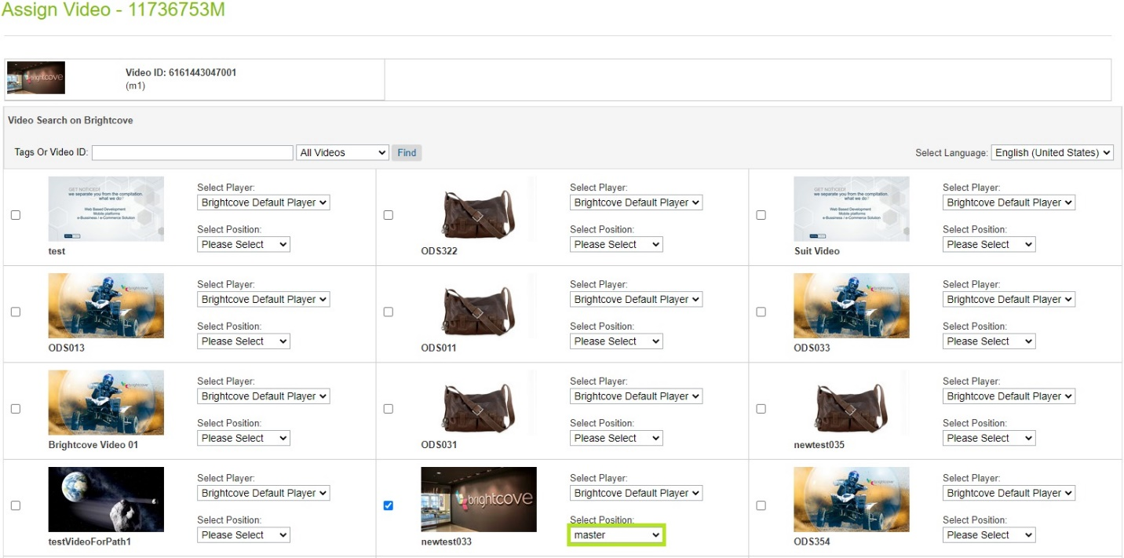

1. Assigned slot cannot be used for the other video(s) for same ***locale***.

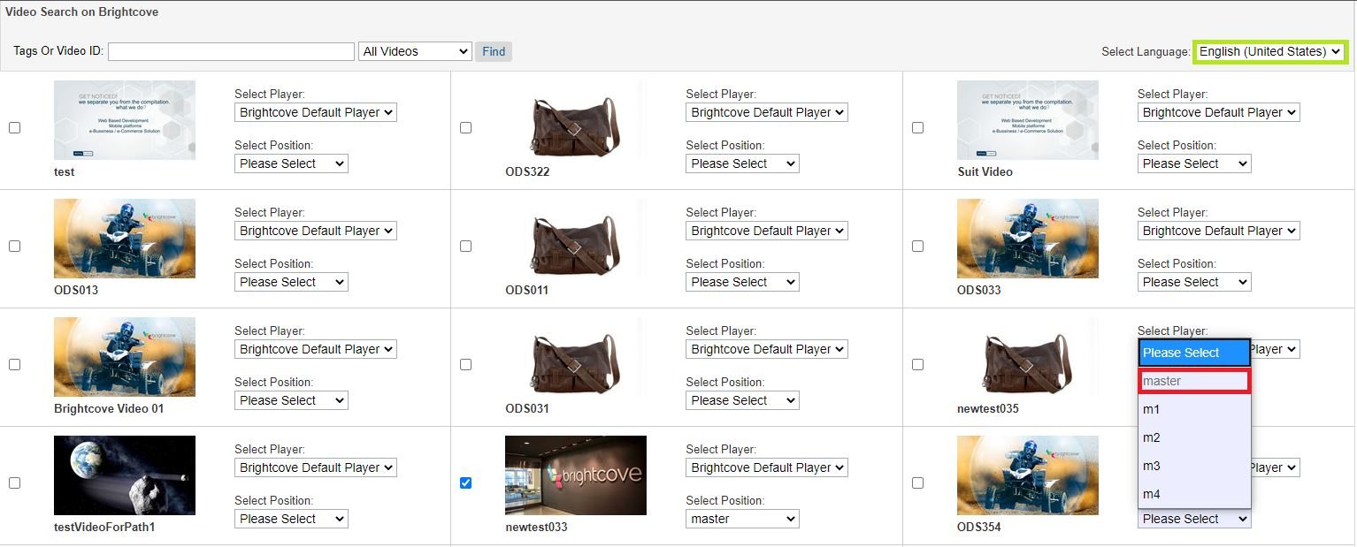

1. Players and slots can be changed by using the respective dropdowns available in each video tile.
2. Select another video with the different slot.
3. Click the Save Video button to assign the selected video(s).

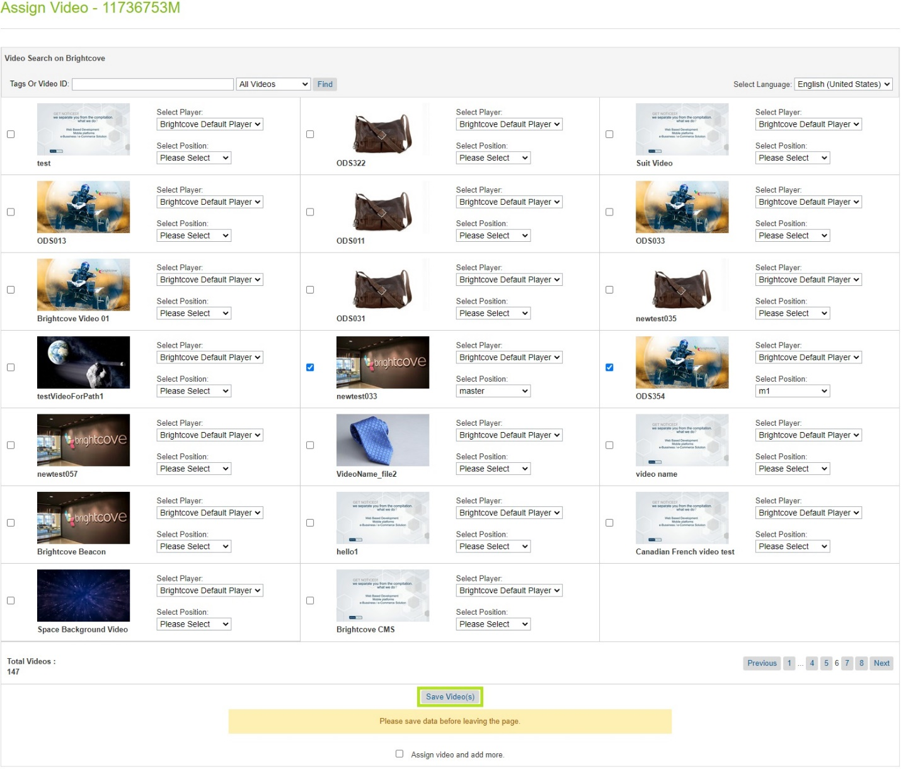

1. Verify the assigned video and the slot.

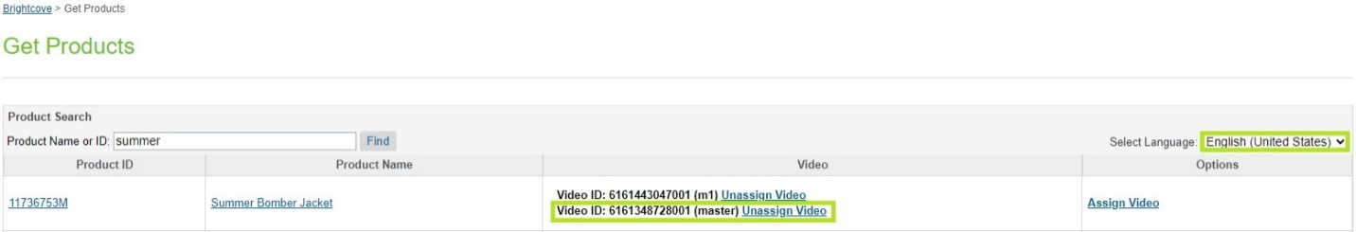

1. Verify the data in product object.
2. Navigate to ***Merchant Tools -> Products***.
3. Search the ***product ID***.
4. Select the ***product***.
5. Select ***General***.
6. Scroll down to the Brightcove section.

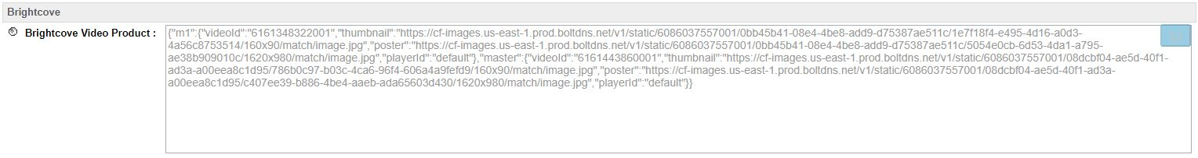

## Variant Products

1. Navigate to ***Merchant Tools -> Brightcove -> Assign Video (Master/Variant Products)****.*
2. Click on the master ***Product ID***.

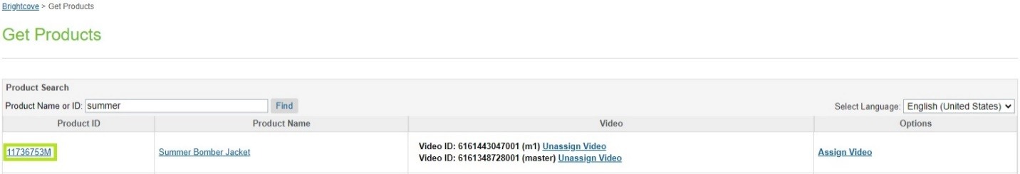

1. List of variants for the selected master will appear.

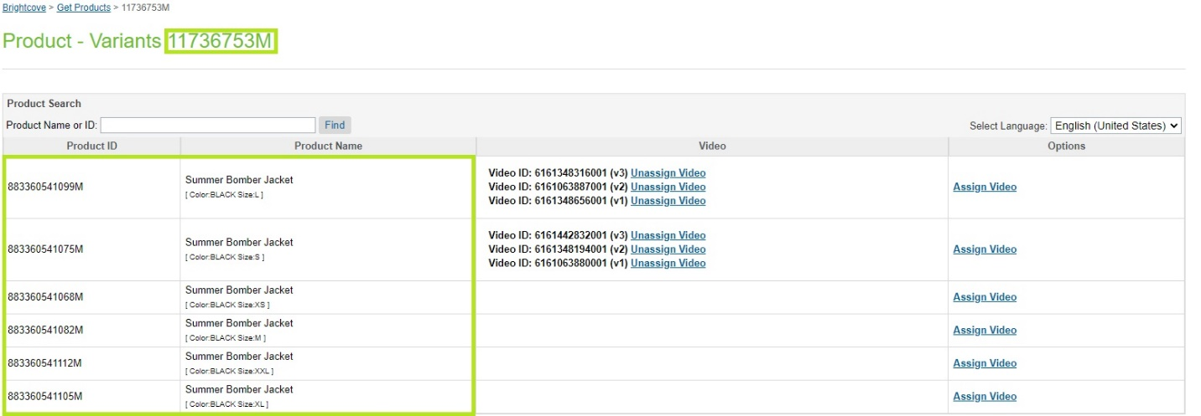

1. Video(s) are assigned to locales.
2. Locale related data can be viewed by changing the locale from the dropdown.
   1. English (United States) – en_US

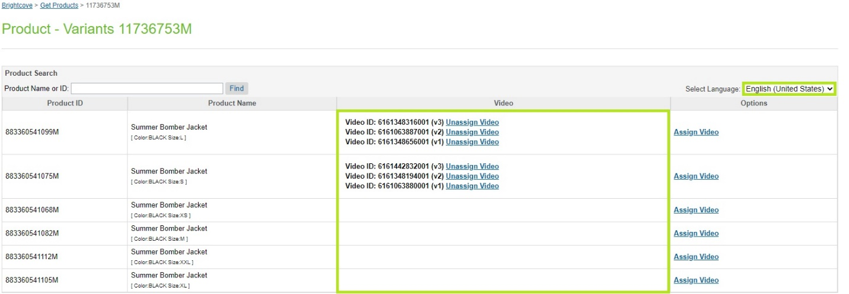

* 1. francias (France) – fr_FR  
     HERE WE SAY “Note that the only locales currently supported are **English (United States)** and **francais (France)”** THIS IS NOT TRUE, PLEASE REMOVE.

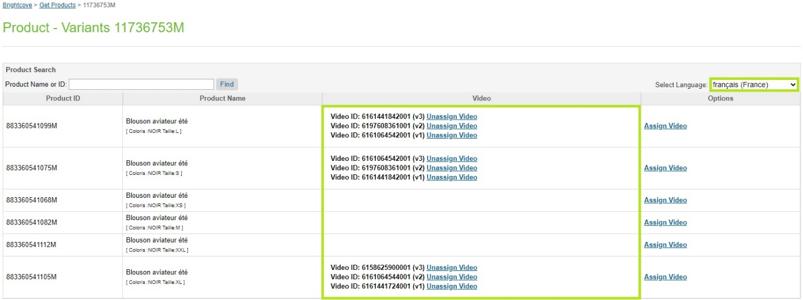

1. Video thumbnail can be viewed by hovering the cursor on ***Video ID***.

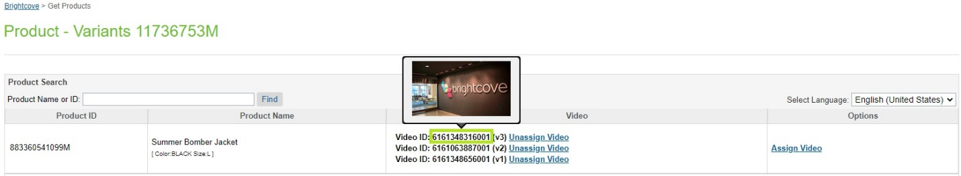

1. Click ***Assign Video*** option to assign video(s).
2. Already assigned video(s) will appear as selected on the assign video(s) grid.

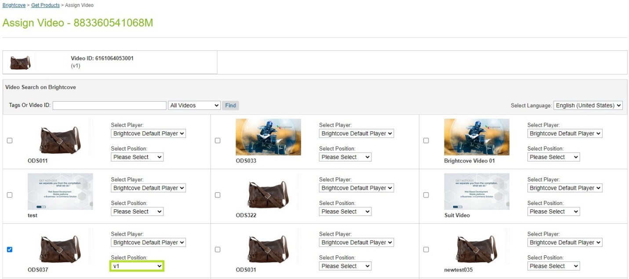

1. Assigned slot cannot be used for the other video(s) for same ***locale***.

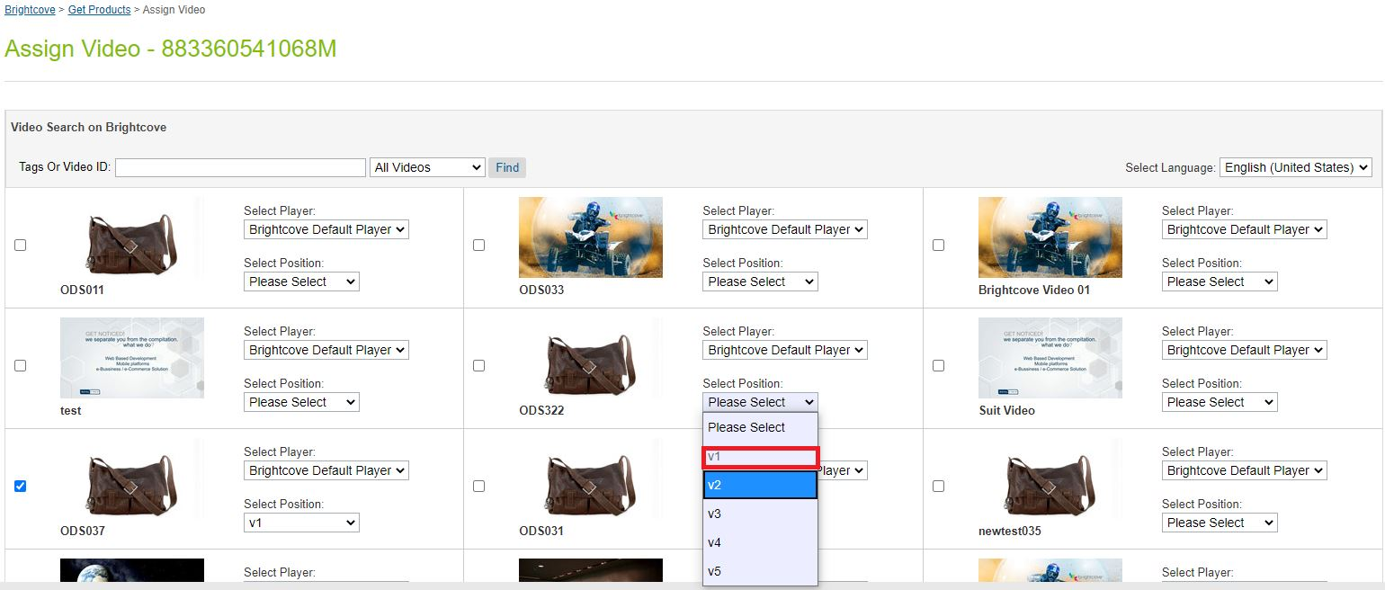

1. Players and slots can be changed by using the respective dropdowns available in each video tile.
2. Select another video with the different slot.
3. Click the Save Video button to assign the selected video(s).

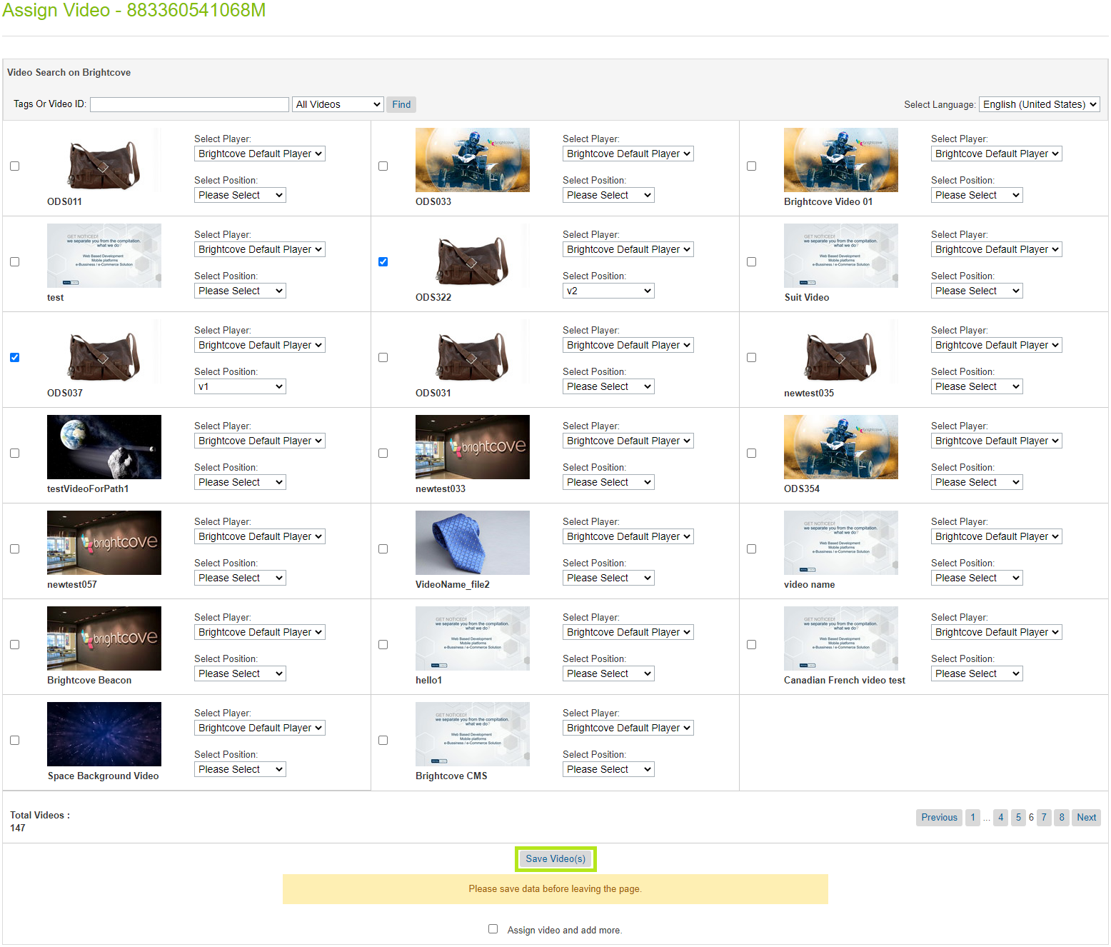

1. Verify the assigned video and the slot.

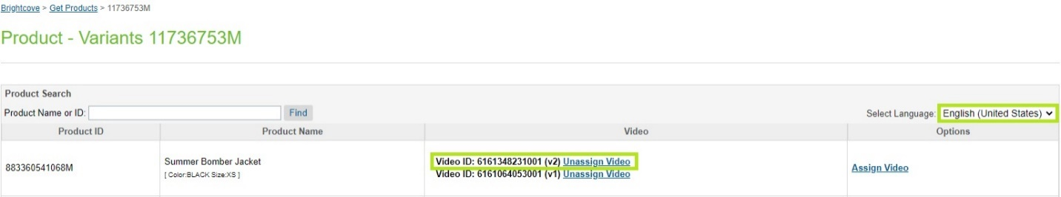

1. Verify the data in product object.
2. Navigate to ***Merchant Tools -> Products***.
3. Search the ***product ID***.
4. Select the ***product***.
5. Select ***General***.
6. Scroll down to the Brightcove section.

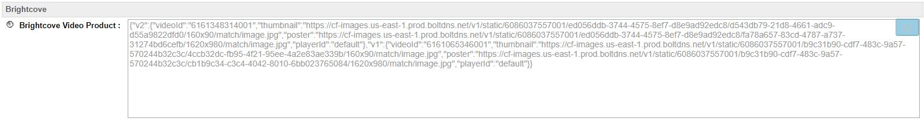

## ALL OF THESE NEW PRODUCT TYPES NEED TO BE ADDED

## Standard Products

1. Navigate to ***Merchant Tools -> Brightcove -> Assign Video (Standard Products)****.*
2. Video(s) are assigned to locales.
3. Locale related data can be viewed by changing the locale from the dropdown.
   1. English (United States) – en_US

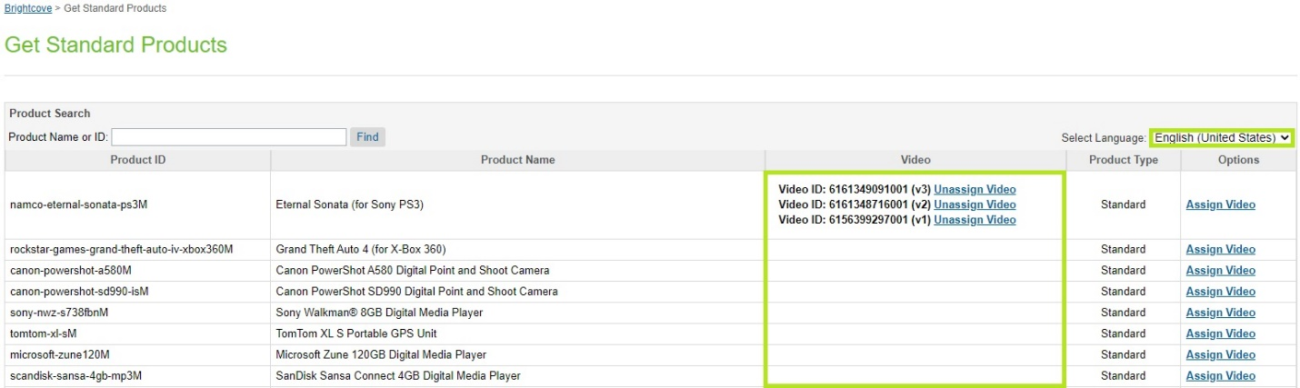

* 1. francias (France) – fr_FR

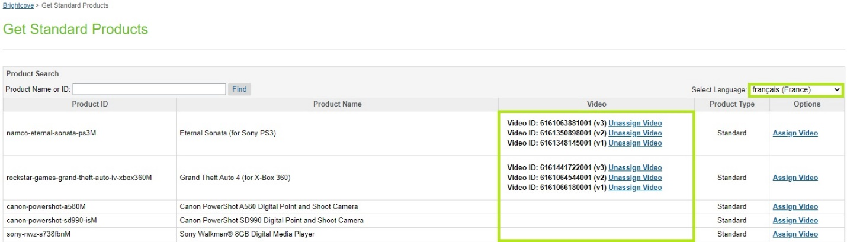

1. Video thumbnail can be viewed by hovering the cursor on ***Video ID***.

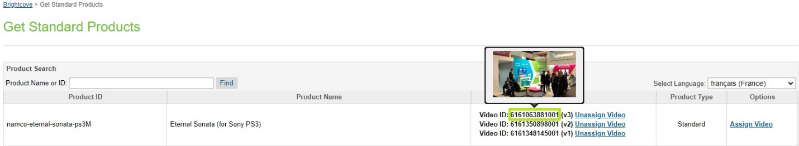

1. Click ***Assign Video*** option to assign video(s).
2. Already assigned video(s) will appear as selected on the assign video(s) grid.

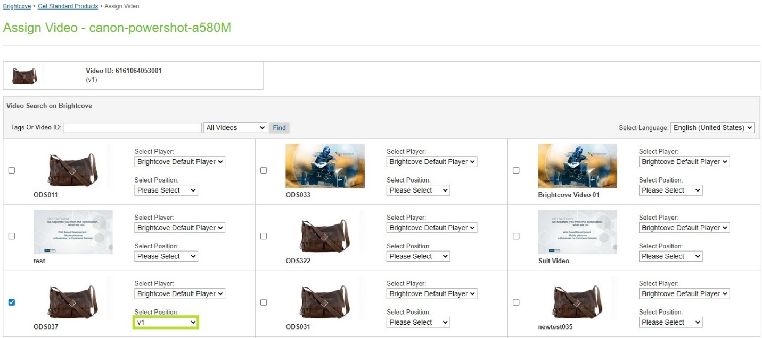

1. Assigned slot cannot be used for the other video(s) for same ***locale***.

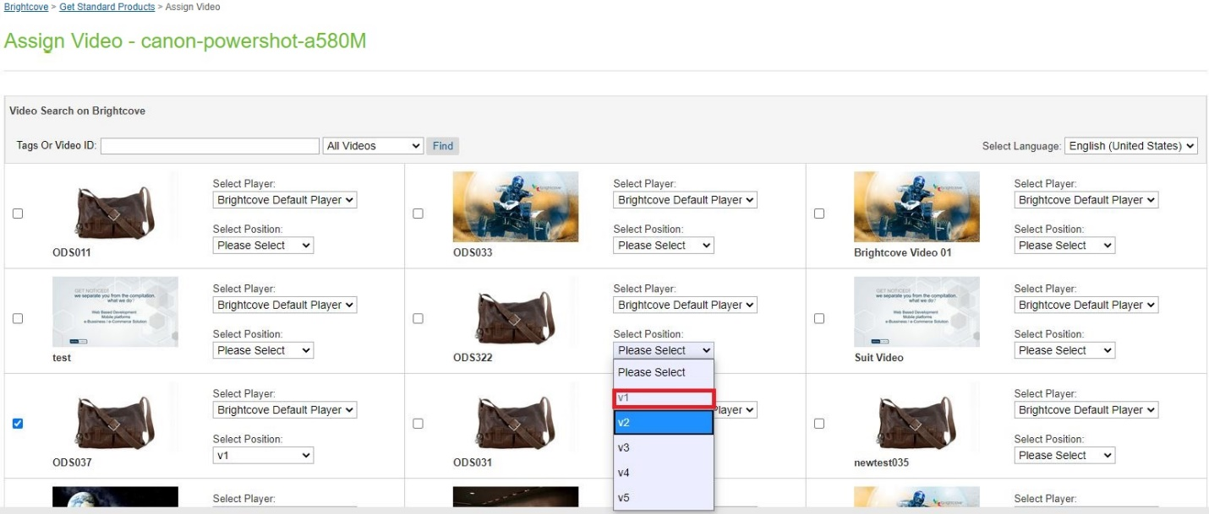

1. Players and slots can be changed by using the respective dropdowns available in each video tile.
2. Select another video with the different slot.
3. Click the Save Video button to assign the selected video(s).

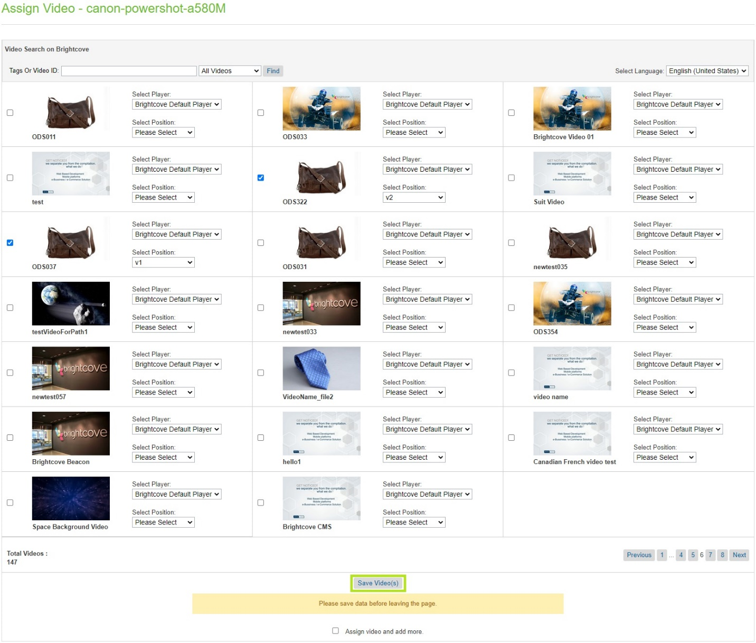

1. Verify the assigned video and the slot.

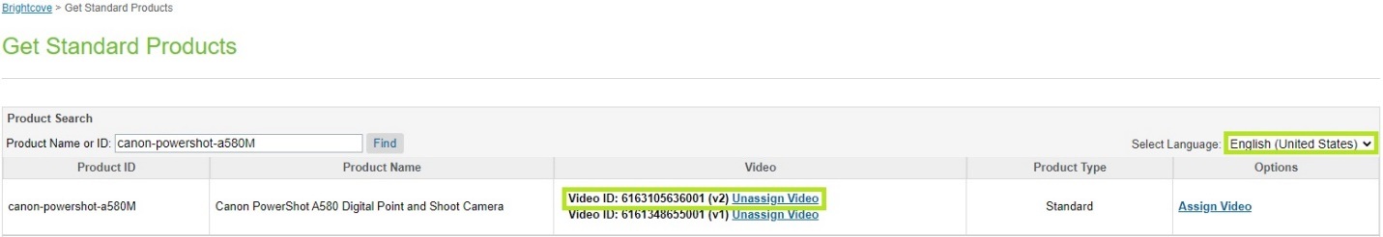

1. Verify the data in product object.
2. Navigate to ***Merchant Tools -> Products***.
3. Search the ***product ID***.
4. Select the ***product***.
5. Select ***General***.
6. Scroll down to the Brightcove section.



## Variation Groups

1. Navigate to ***Merchant Tools -> Brightcove -> Assign Video (Variation Groups)****.*
2. Video(s) are assigned to locales.
3. Locale related data can be viewed by changing the locale from the dropdown.
   1. English (United States) – en_US

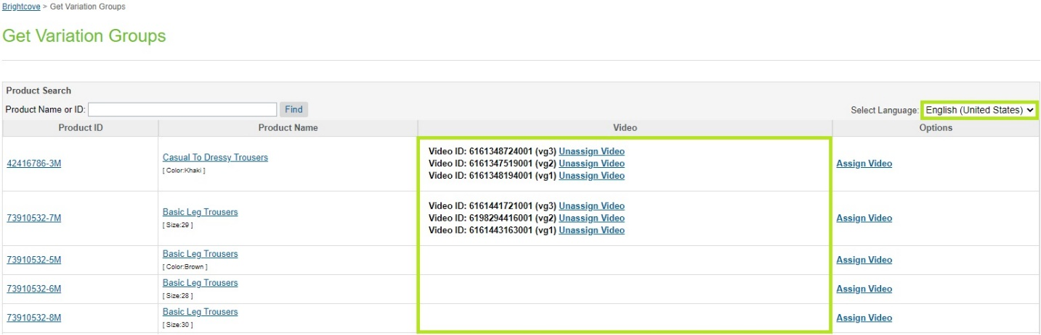

* 1. francias (France) – fr_FR

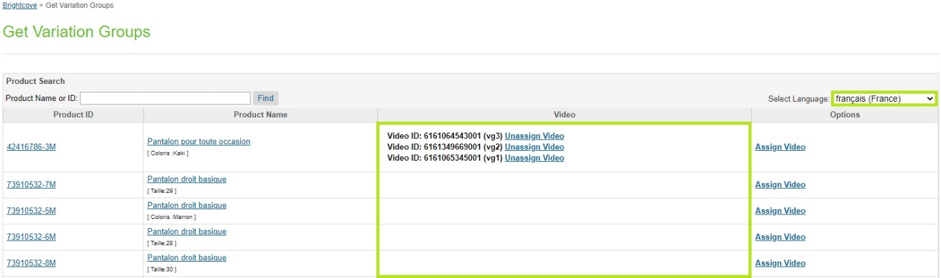

1. Video thumbnail can be viewed by hovering the cursor on ***Video ID***.

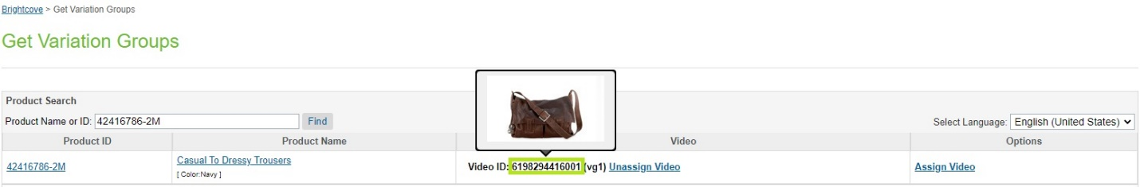

1. Click ***Assign Video*** option to assign video(s).
2. Already assigned video(s) will appear as selected on the assign video(s) grid.

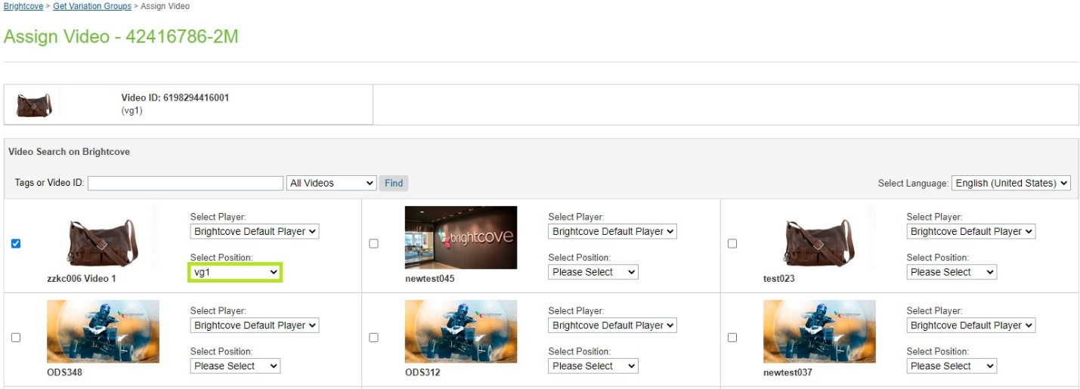

1. Assigned slot cannot be used for the other video(s) for same ***locale***.

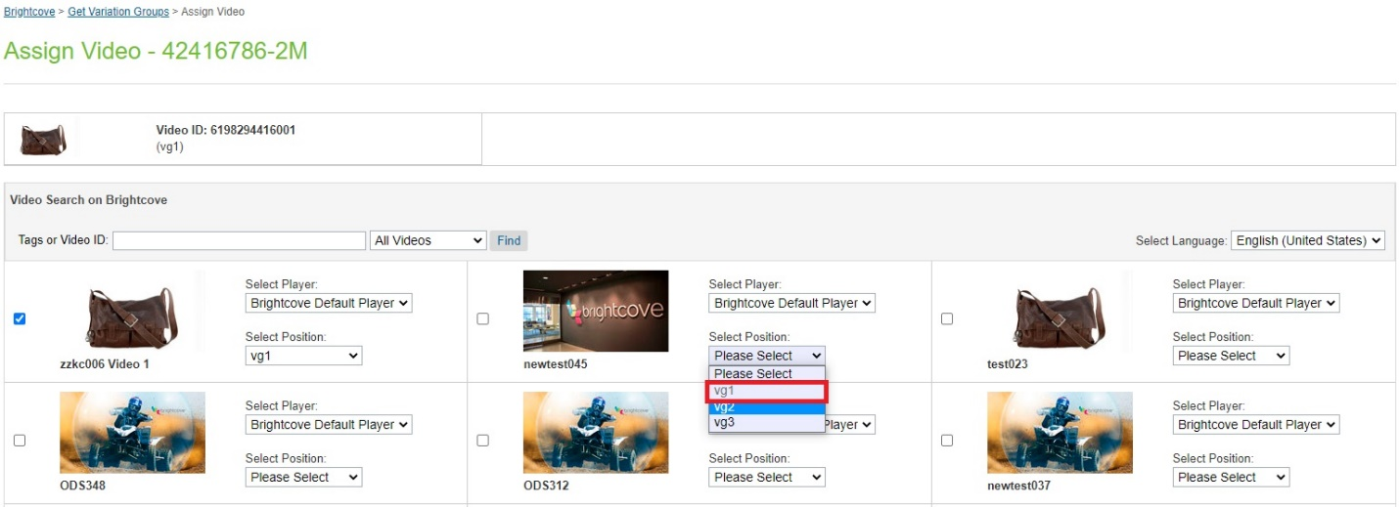

1. Players and slots can be changed by using the respective dropdowns available in each video tile.
2. Select another video with the different slot.
3. Click the Save Video button to assign the selected video(s).

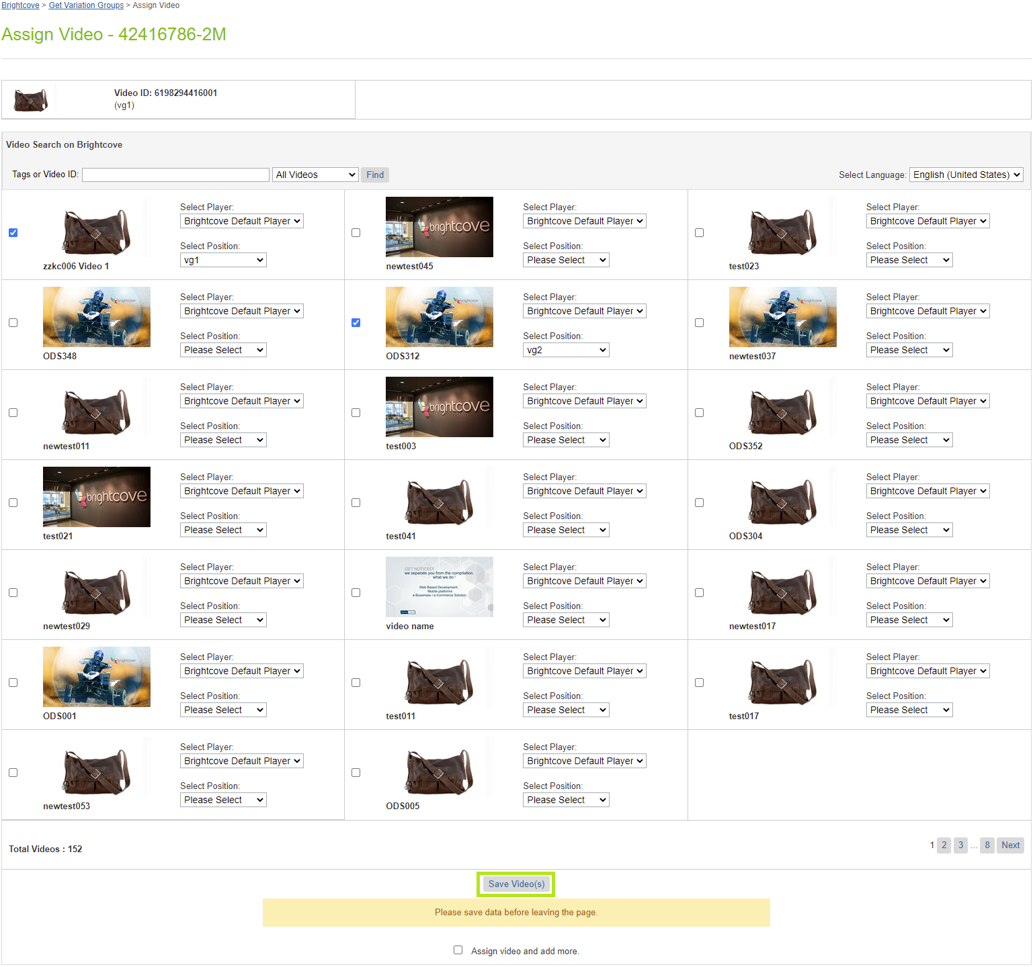

1. Verify the assigned video and the slot.

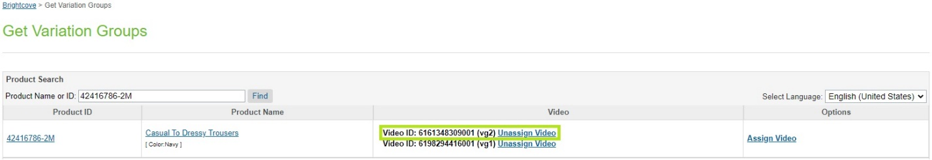

1. Verify the data in product object.
2. Navigate to ***Merchant Tools -> Products***.
3. Search the ***product ID***.
4. Select the ***product***.
5. Select ***General***.
6. Scroll down to the Brightcove section.

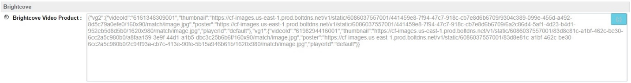

1. We can navigate to assigned variants of the Variation Group.
2. Select Variation Group ID.

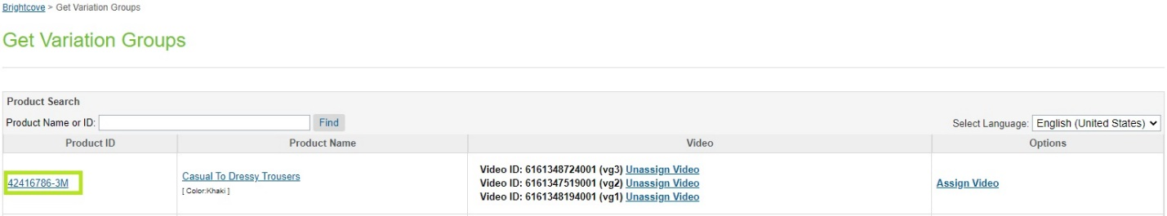

1. List of variants for the selected variation group will appear.

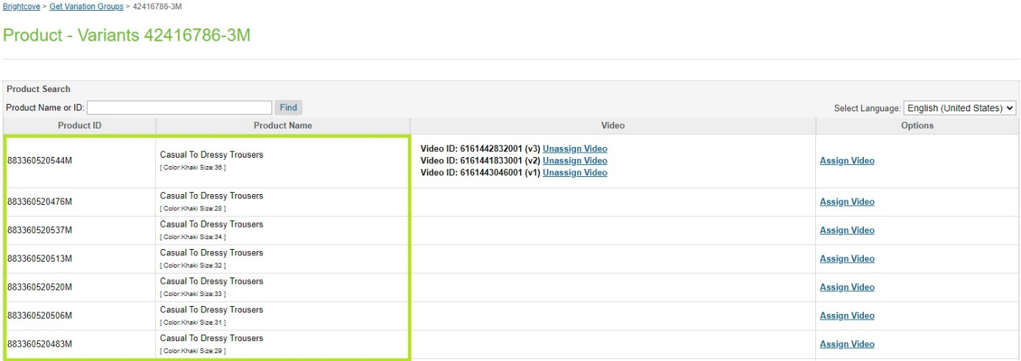

## Product Sets

1. Navigate to ***Merchant Tools -> Brightcove -> Assign Video (Product Sets)****.*
2. Video(s) are assigned to locales.
3. Locale related data can be viewed by changing the locale from the dropdown.
   1. English (United States) – en_US

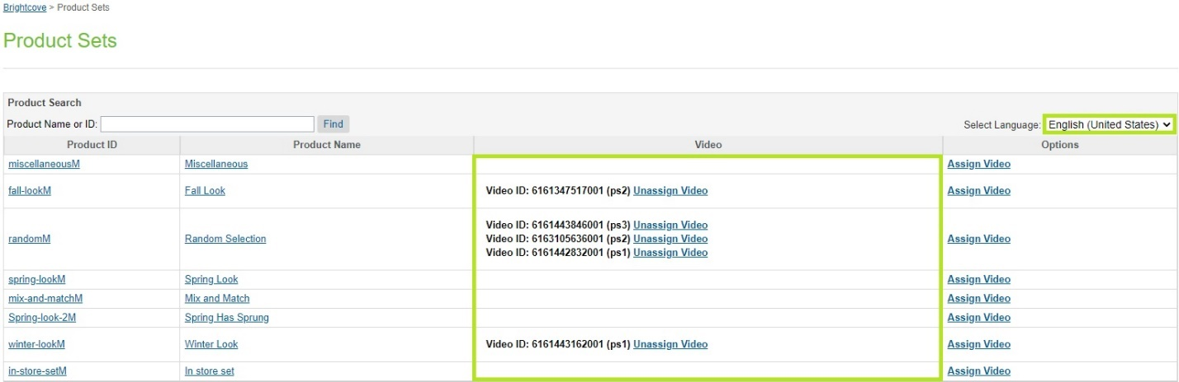

* 1. francias (France) – fr_FR

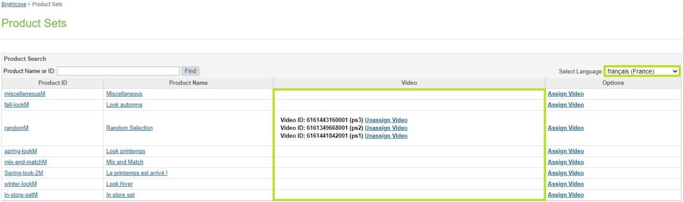

1. Video thumbnail can be viewed by hovering the cursor on ***Video ID***.

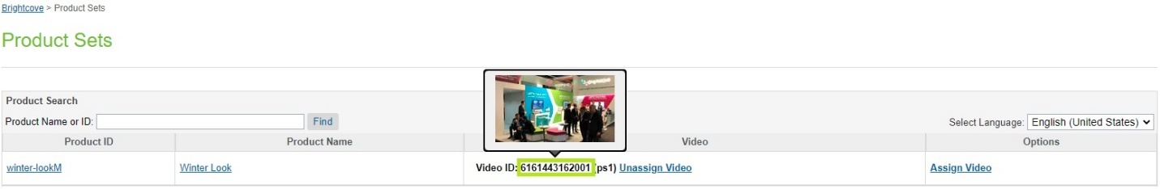

1. Click ***Assign Video*** option to assign video(s).
2. Already assigned video(s) will appear as selected on the assign video(s) grid.

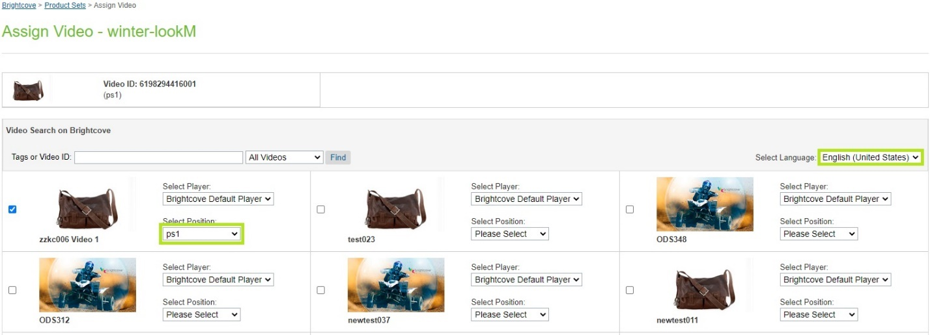

1. Assigned slot cannot be used for the other video(s) for same ***locale***.

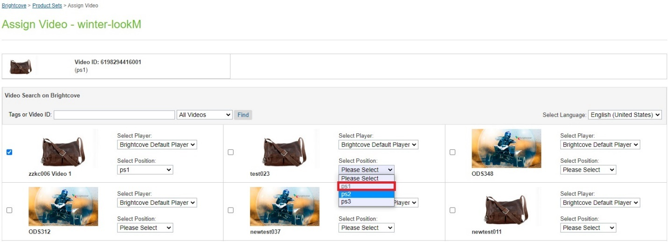

1. Players and slots can be changed by using the respective dropdowns available in each video tile.
2. Select another video with the different slot.
3. Click the Save Video button to assign the selected video(s).

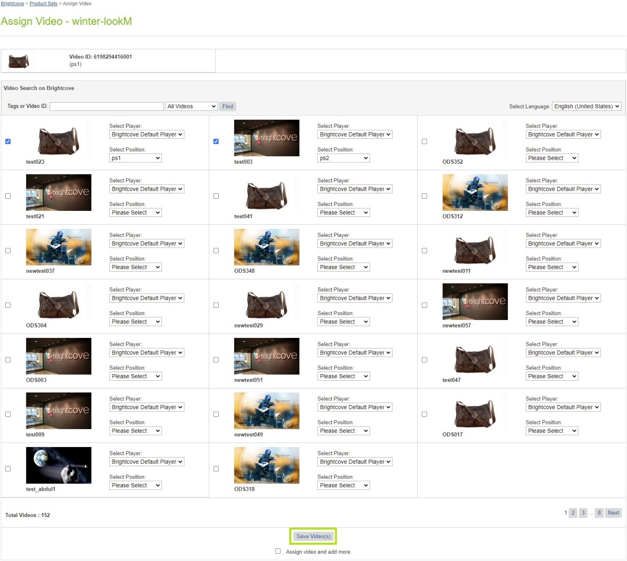

1. Verify the assigned video and the slot.

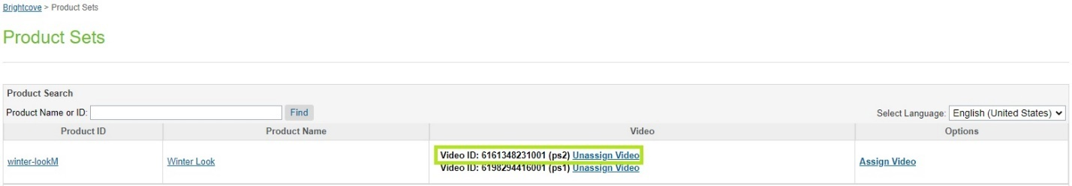

1. Verify the data in product object.
2. Navigate to ***Merchant Tools -> Products***.
3. Search the ***product ID***.
4. Select the ***product***.
5. Select ***General***.
6. Scroll down to the Brightcove section.

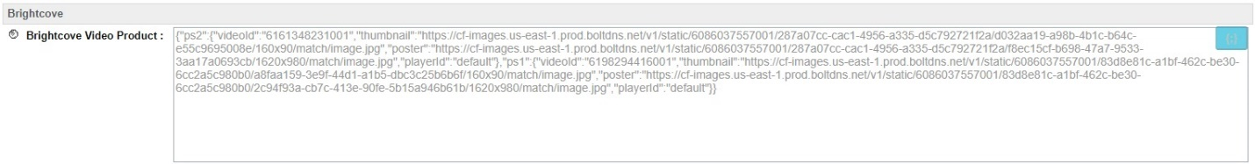

1. We can navigate to assigned products of the Product Set.
2. Select Product Set ID.

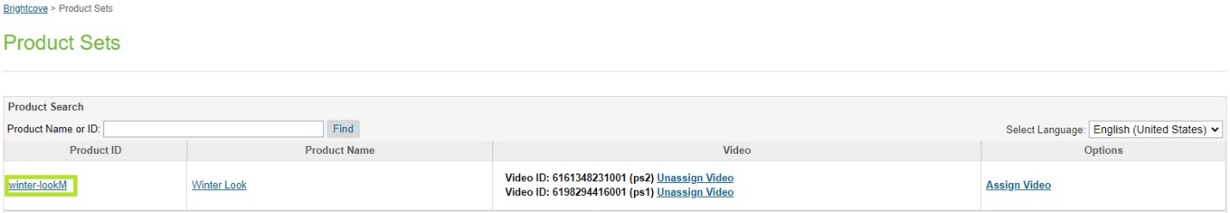

1. List of products for the selected product set will appear.

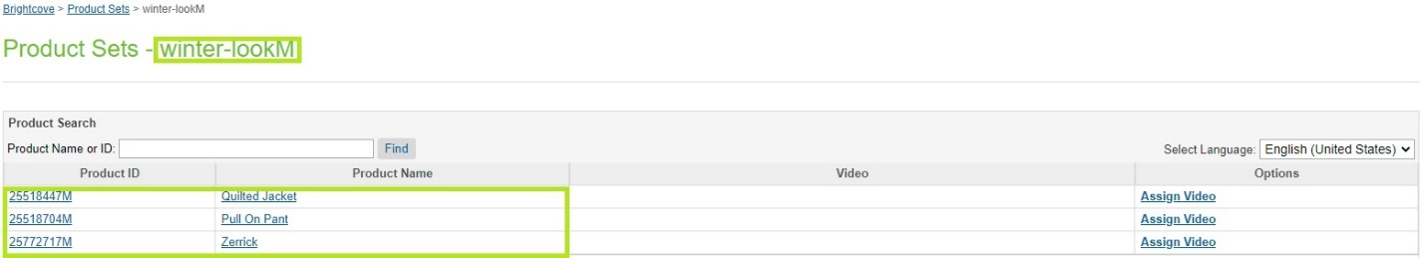

## Product Bundles

1. Navigate to ***Merchant Tools -> Brightcove -> Assign Video (Product Bundles)****.*
2. Video(s) are assigned to locales.
3. Locale related data can be viewed by changing the locale from the dropdown.
   1. English (United States) – en_US

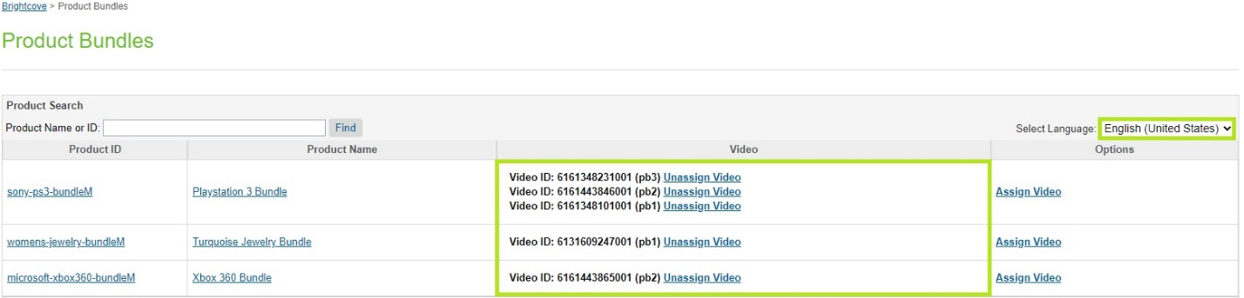

* 1. francias (France) – fr_FR

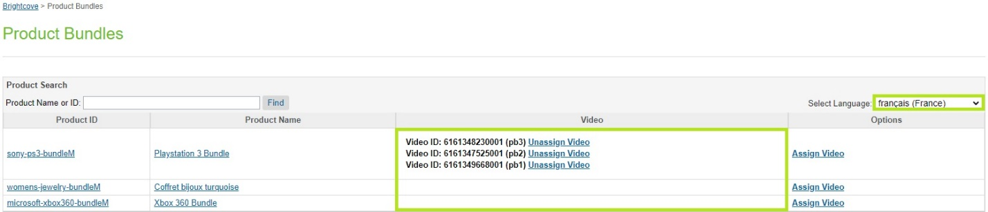

1. Video thumbnail can be viewed by hovering the cursor on ***Video ID***.

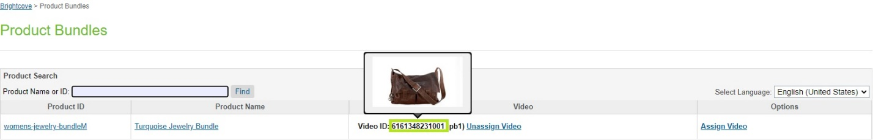

1. Click ***Assign Video*** option to assign video(s).
2. Already assigned video(s) will appear as selected on the assign video(s) grid.

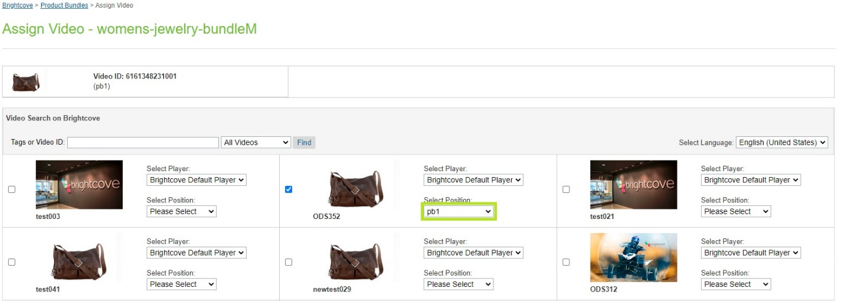

1. Assigned slot cannot be used for the other video(s) for same ***locale***.

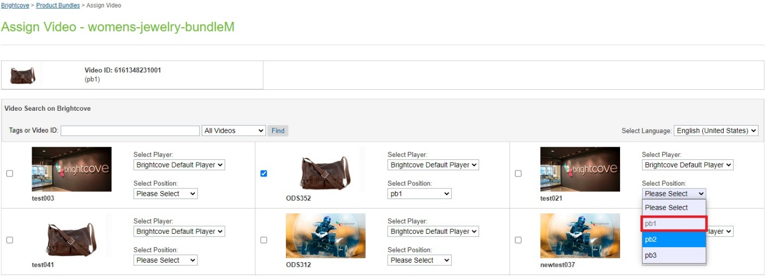

1. Players and slots can be changed by using the respective dropdowns available in each video tile.
2. Select another video with the different slot.
3. Click the Save Video button to assign the selected video(s).

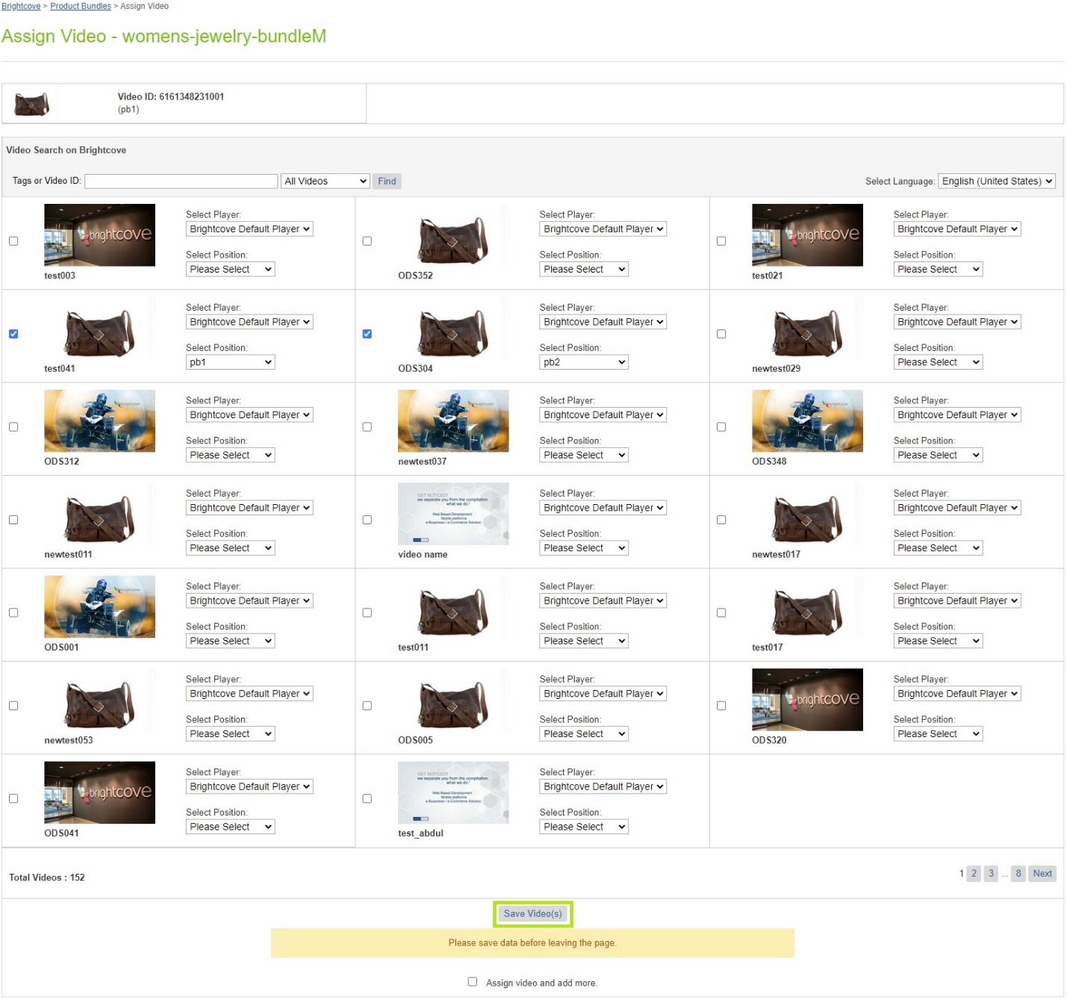

1. Verify the assigned video and the slot.

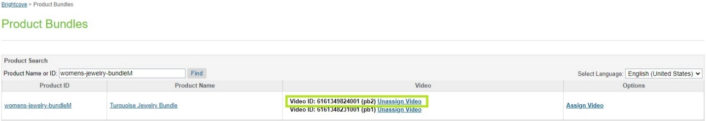

1. Verify the data in product object.
2. Navigate to ***Merchant Tools -> Products***.
3. Search the ***product ID***.
4. Select the ***product***.
5. Select ***General***.
6. Scroll down to the Brightcove section.

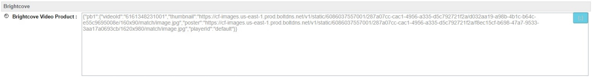

1. We can navigate to assigned products of the Product Set.
2. Select Product Set ID.

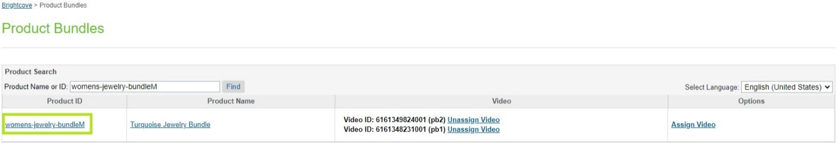

1. List of products for the selected product set will appear.

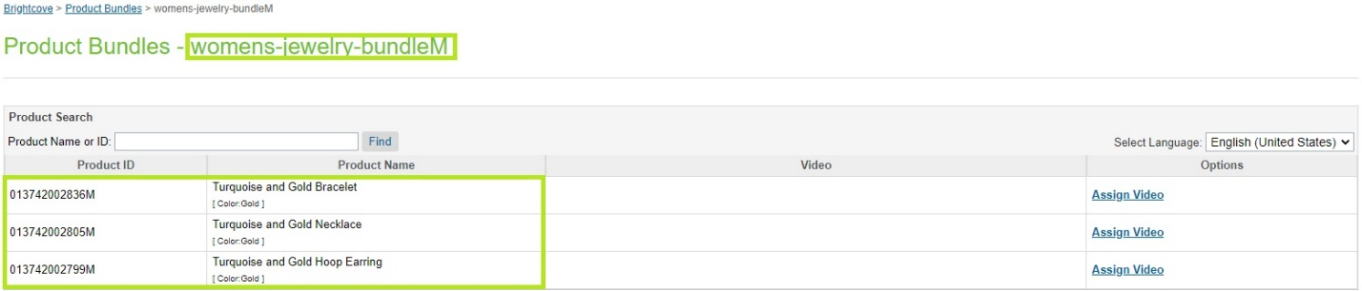

# Embed Video

1. Embed video allows to get code to render video(s) on any ISML page.
2. Navigate to ***Merchant Tools -> Brightcove -> Embed Video***.
3. Select Video and player from the dropdown and click ***Get Code***.

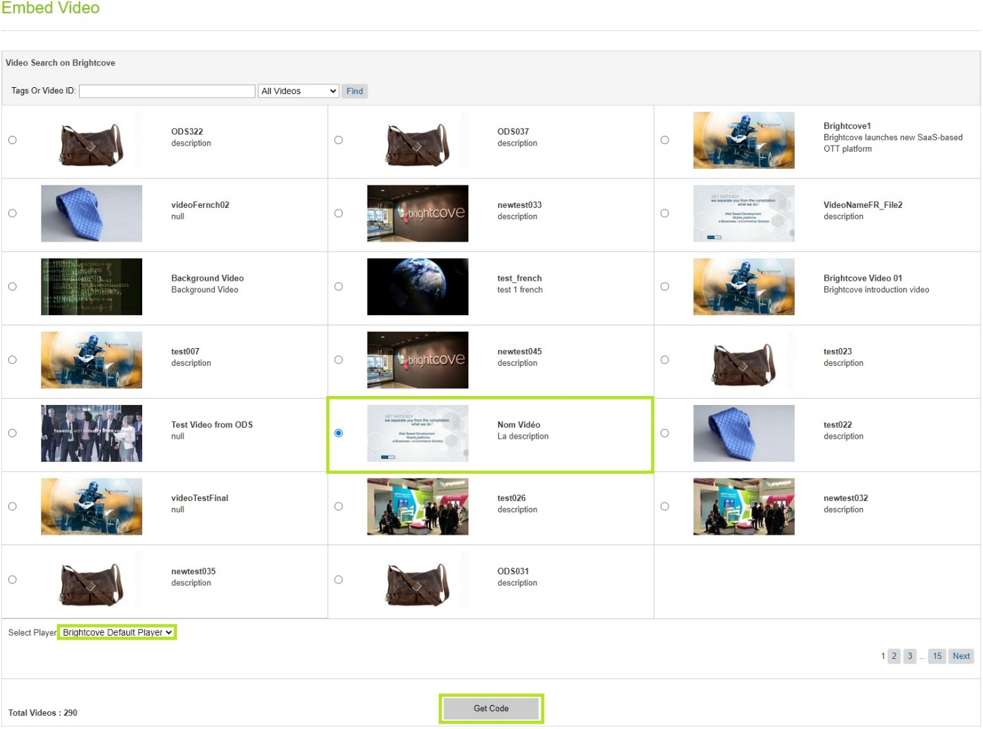

1. Popup will appear to get the code.
2. Select the code block, it will get copied to the clipboard.

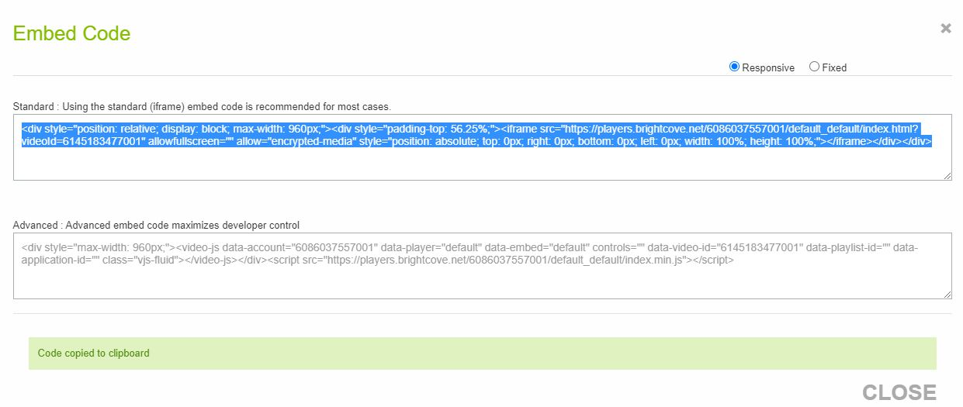

1. Paste the code in content asset, content slot or in any ISML template to render video.

# Bulk Upload

1. Bulk upload allows to ingest videos in bulk quantity by uploading .csv file(s).
2. The job will process the .csv file(s) and ingest the videos to the Brightcove account.
3. The sample bulkUpload file is attached in the ***zip file*** under ***meta*** directory.
4. videofile, videoposter and videothumbnail should be available on publicly accessible path.
5. Navigate to ***Merchant Tools -> Brightcove -> Bulk Upload***.
6. Select .csv file.
7. Click submit.

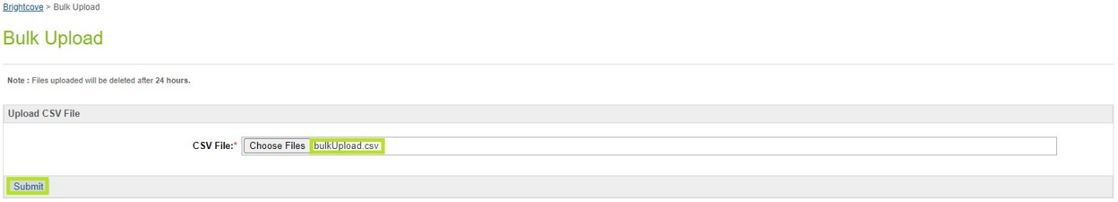

1. The file will upload in ***Temp*** directory under ***bulkUpload*** folder.



1. File data.

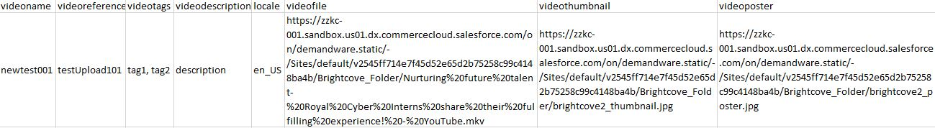

1. Navigate to ***Administration -> Jobs***.
2. Select ***Bulk-Upload*** job and click ***Run***.
3. Verify the job completion status.

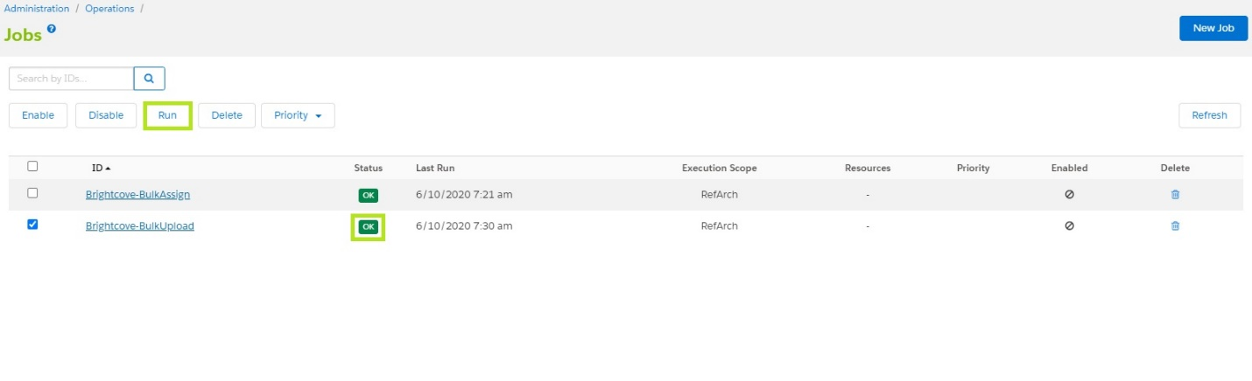

1. Verify the video object in Brightcove account.

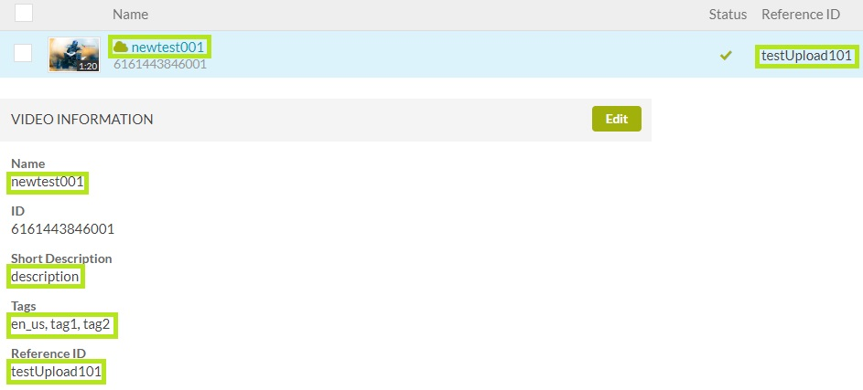

1. The file processed by ***Bulk-Upload*** job will be moved to ***bulkUpload_processed*** folder under ***Temp*** directory.



# Bulk Assign

***Note: If the locale provided in csv file is not available for the site, video(s) will be assigned to the default locale of the site.***

1. Bulk assign allows to assign video(s) to categories, sub-categories and products in bulk quantity by uploading .csv file(s).
2. The job will process the .csv file(s) and assign the video(s).
3. The sample bulkAssign file(s) for category and product are attached in the ***zip file*** under ***meta*** directory.
4. The job will process csv file(s) for category and product under the same execution.
5. The job checks the directories for product and category and process the file(s).

## Category

1. Navigate to ***Merchant Tools -> Brightcove -> Bulk Assign***.
2. Select ***Category***.
3. Select .csv file.
4. Click submit.

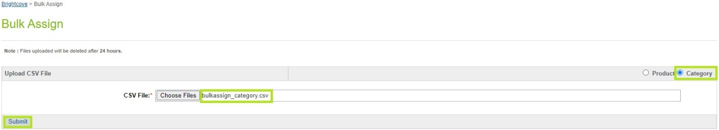

1. The file will upload in ***Temp*** directory under ***<SITE-ID>/bulkAssignCategory*** folder.



1. File data.

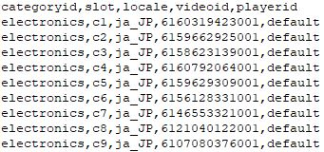

1. Navigate to ***Administration -> Jobs***.
2. Select ***Bulk-Assign*** job and click ***Run***.
3. Verify the job completion status.

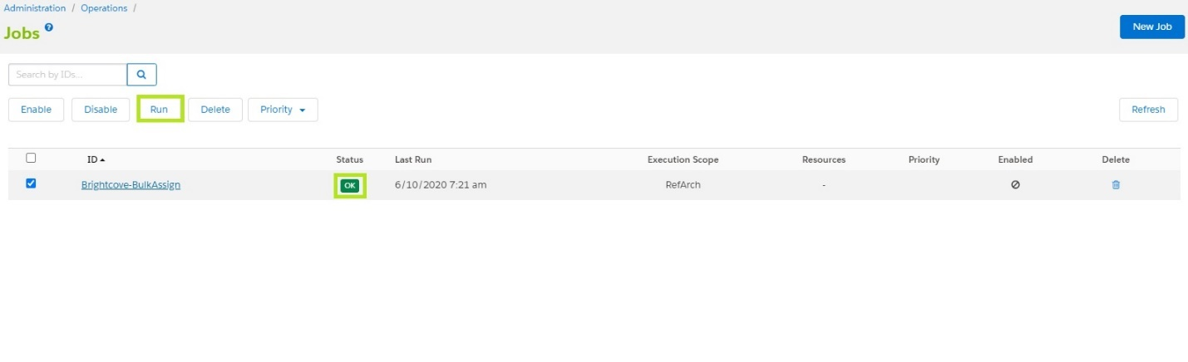

1. Verify the video(s) assigned.

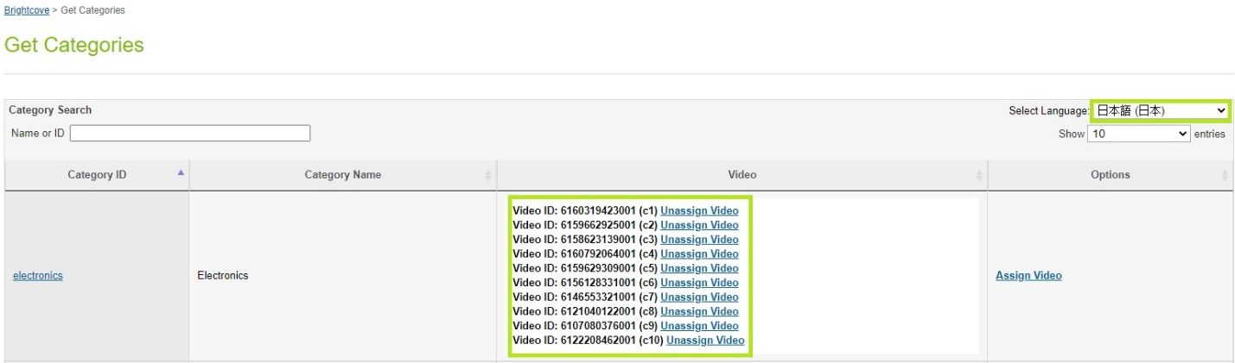

1. The file processed by ***Bulk-Assign*** job will be moved to ***bulkAssignCategory_processed*** folder under ***Temp*** directory.



## Product

1. Navigate to ***Merchant Tools -> Brightcove -> Bulk Assign***.
2. Select ***Product***.
3. Select .csv file.
4. Click submit.

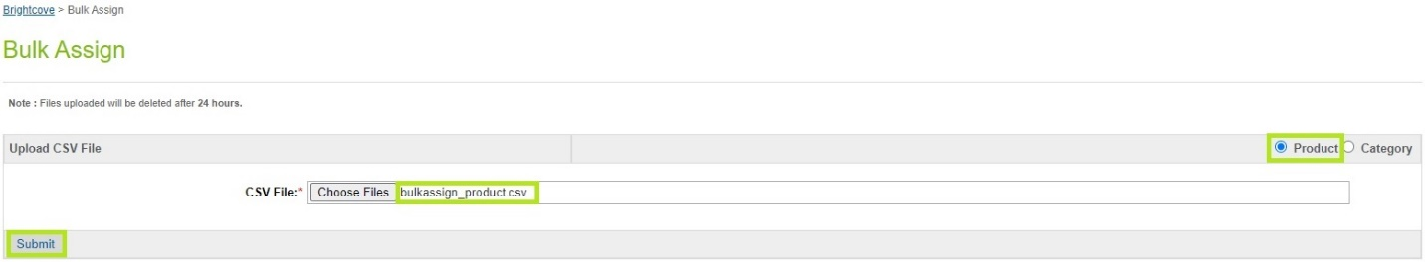

1. The file will upload in ***Temp*** directory under ***<SITE-ID>/bulkAssignProduct*** folder.



1. File data.

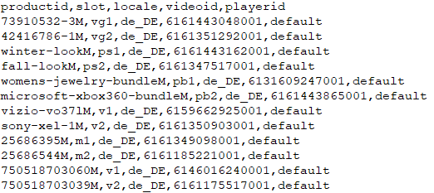

1. Navigate to ***Administration -> Jobs***.
2. Select ***Bulk-Assign*** job and click ***Run***.
3. Verify the job completion status.



1. Verify the video(s) assigned.

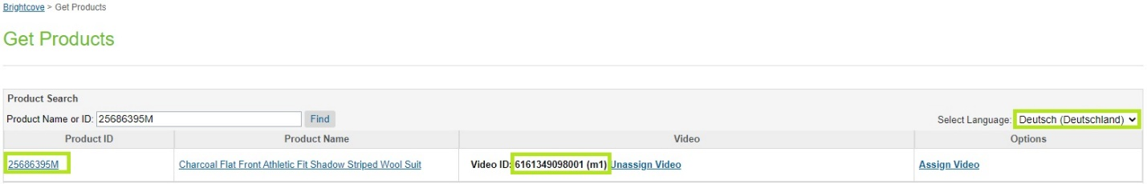

1. The file processed by ***Bulk-Assign*** job will be moved to ***bulkAssignProduct_processed*** folder under ***Temp*** directory.



# Storefront Reference Architecture (SFRA)

## Category (catlanding, searchResultsNoDecorator)

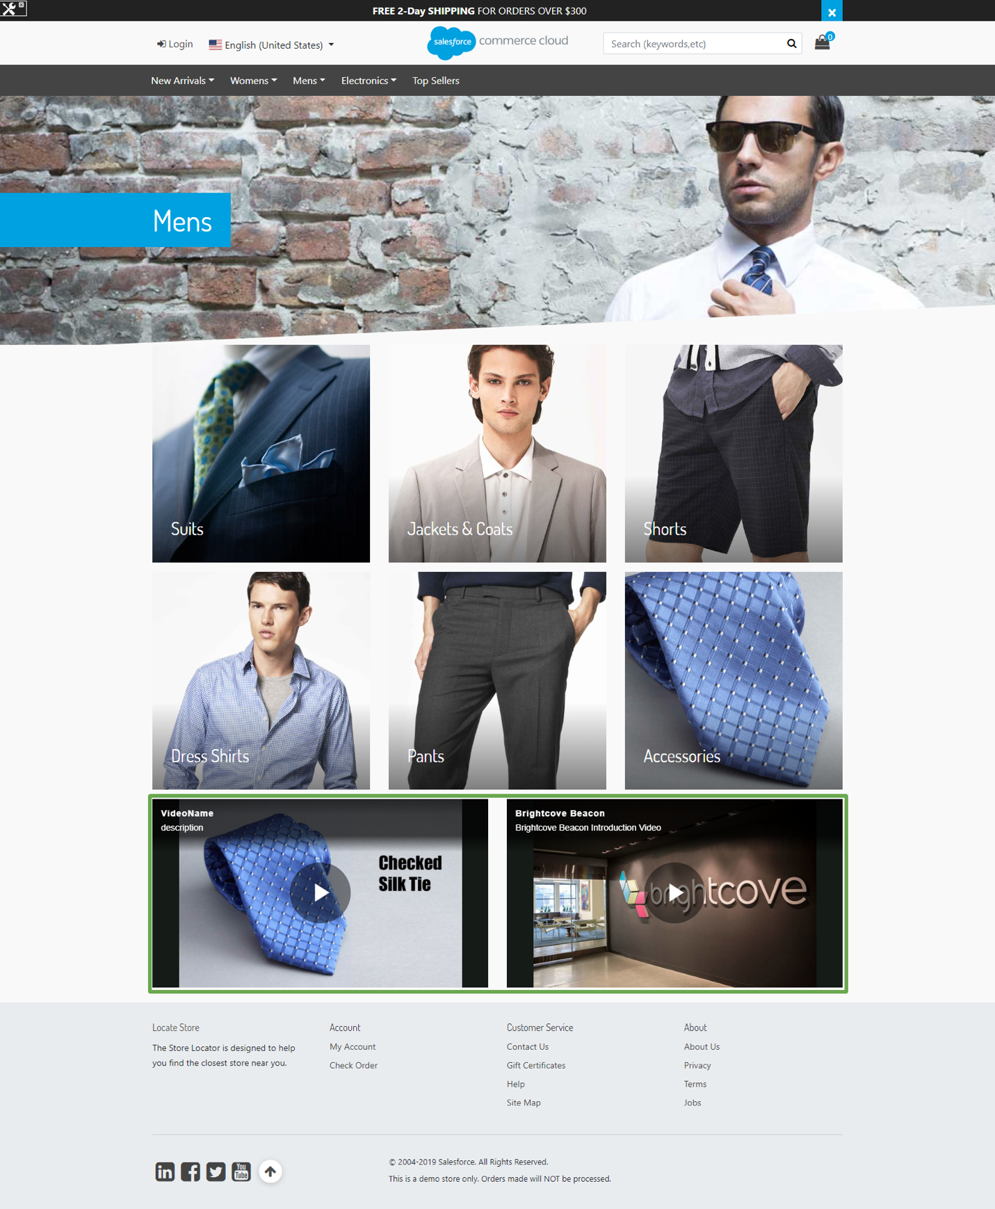

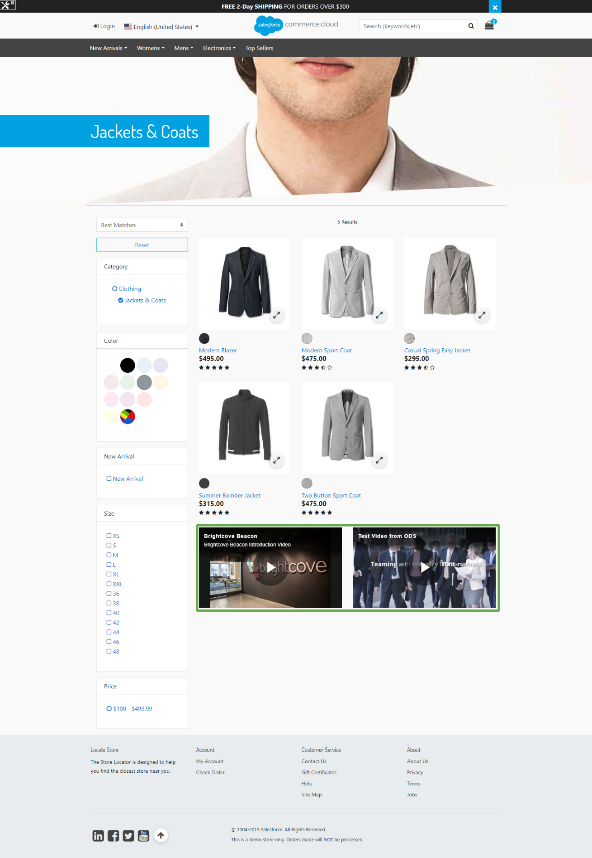

## Product Page Master / Variant Products(productDetails)

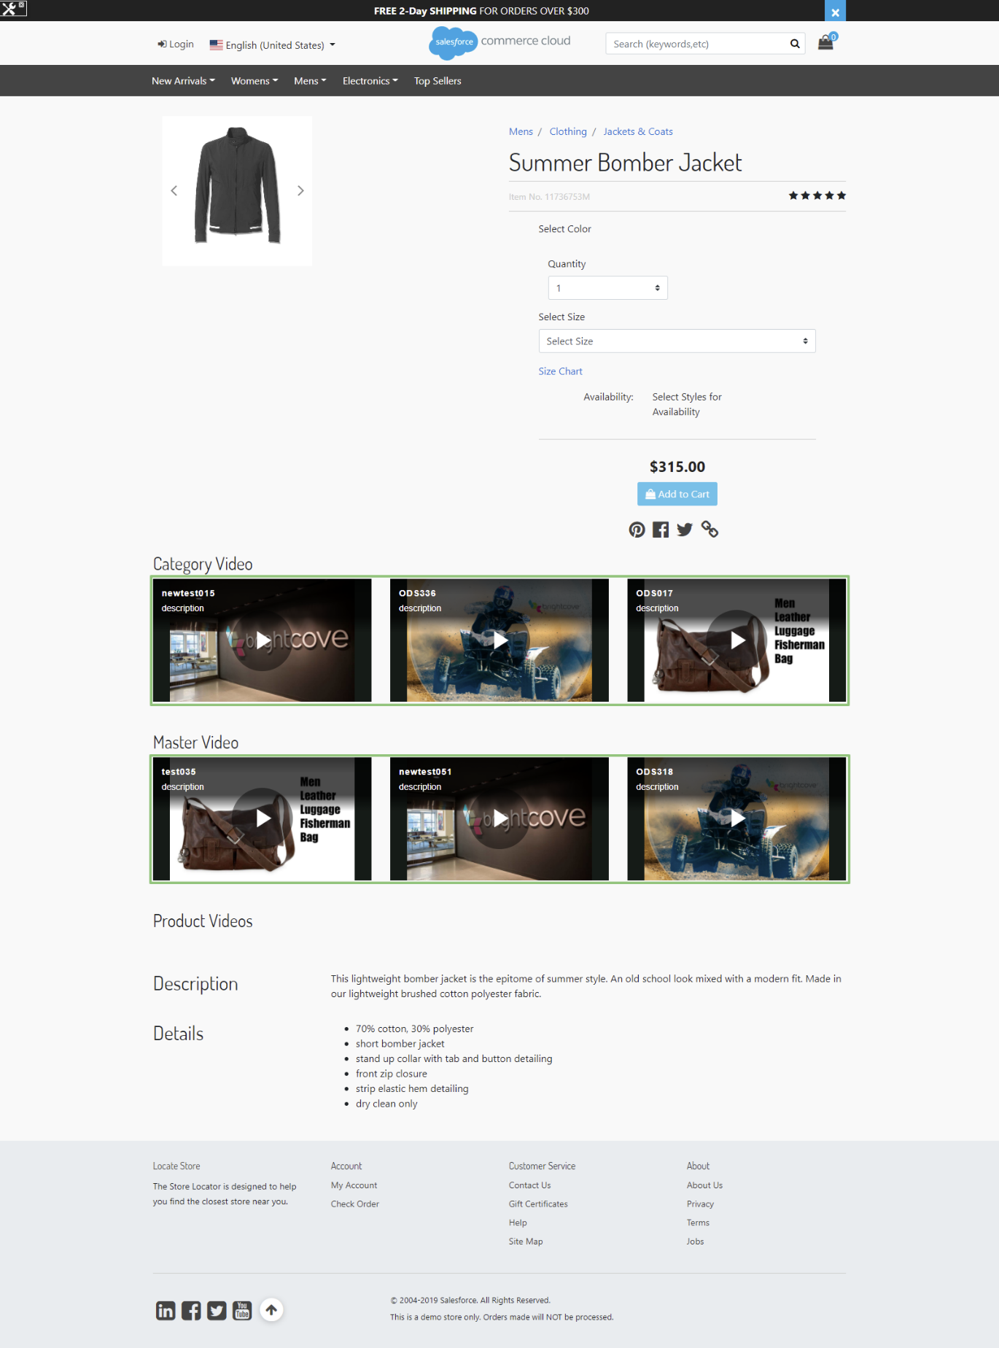

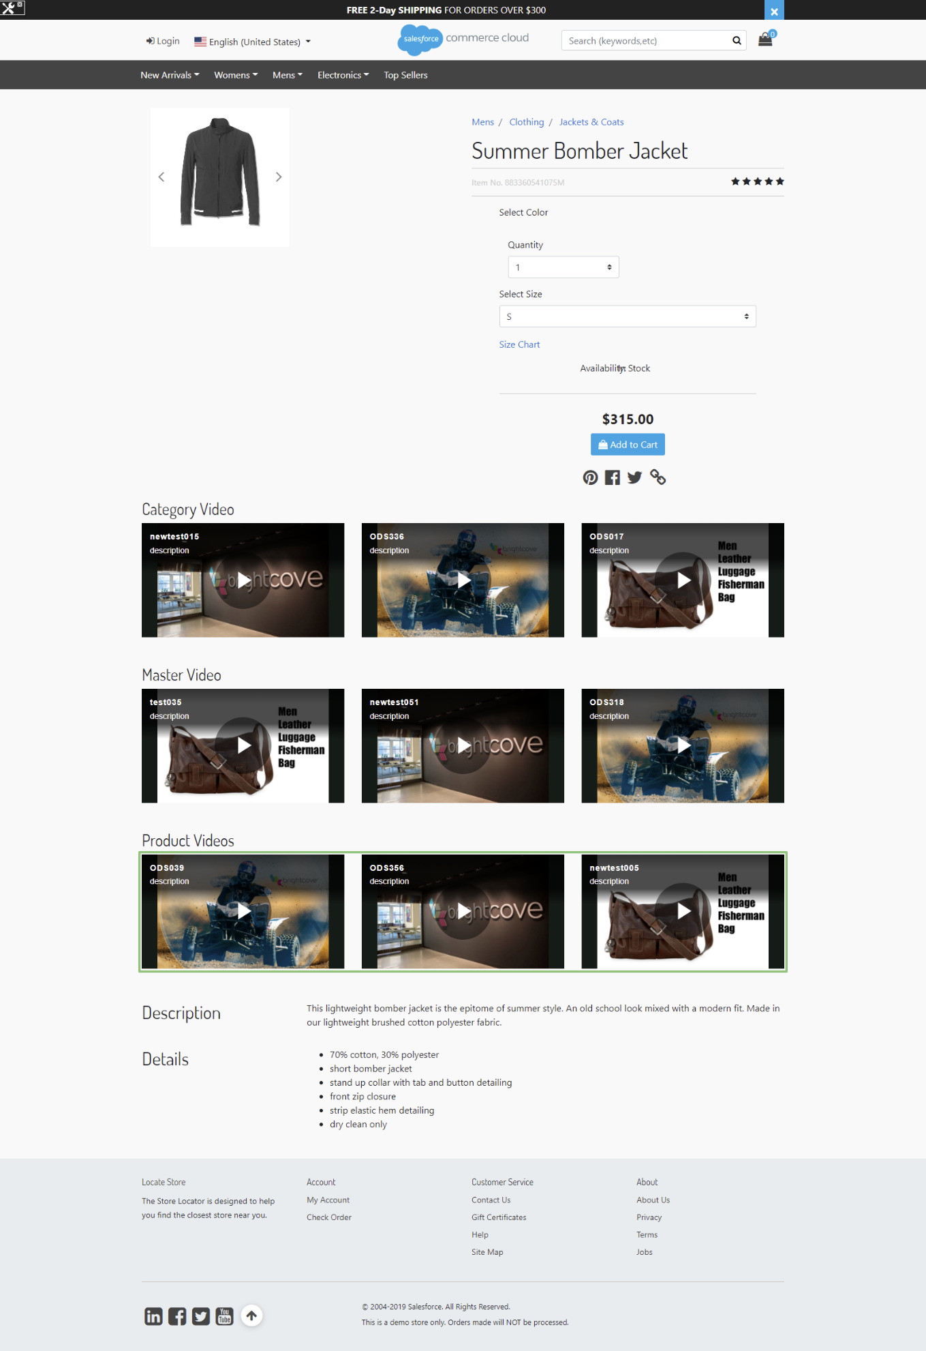

## Product Page – Standard Products(productDetails)

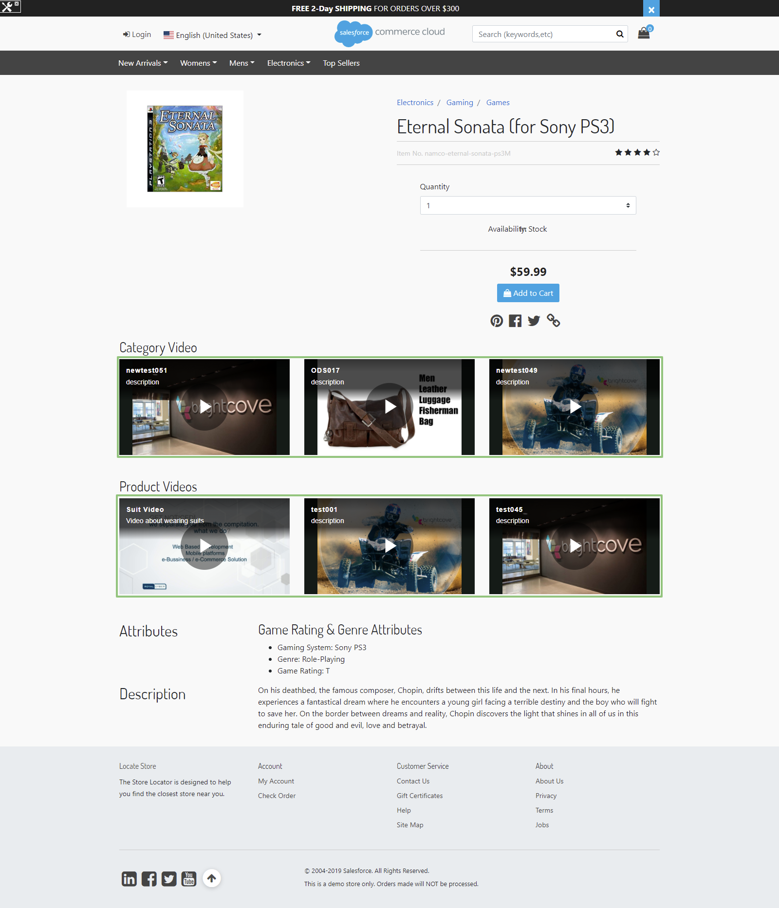

## Product Page – Variation Group(productDetails)

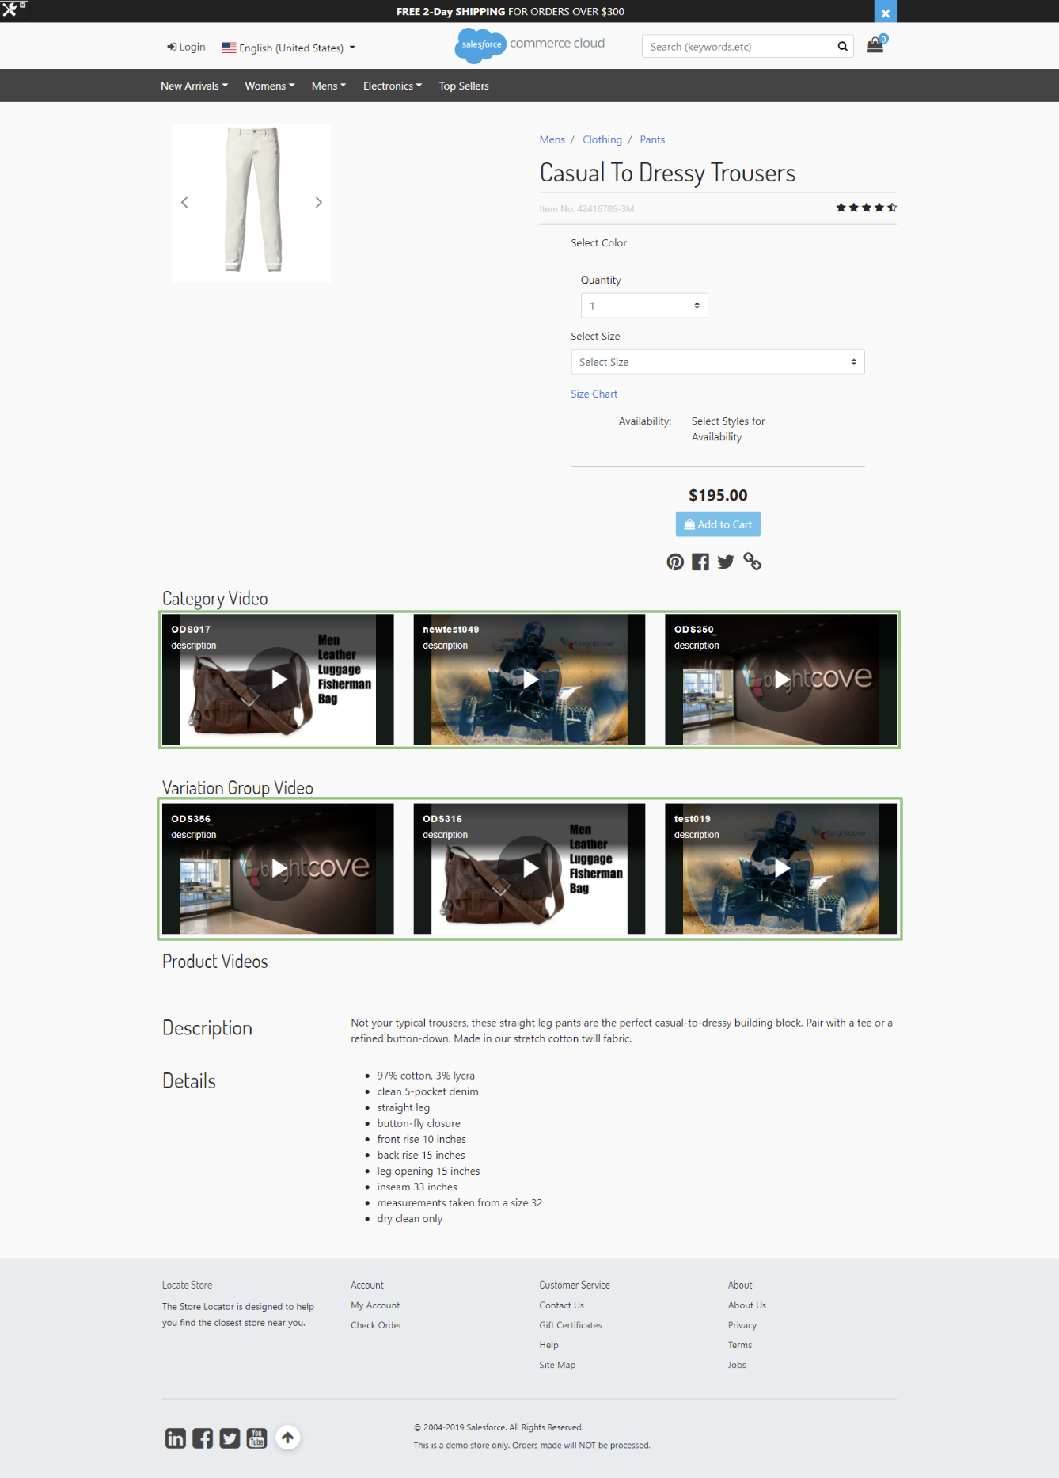

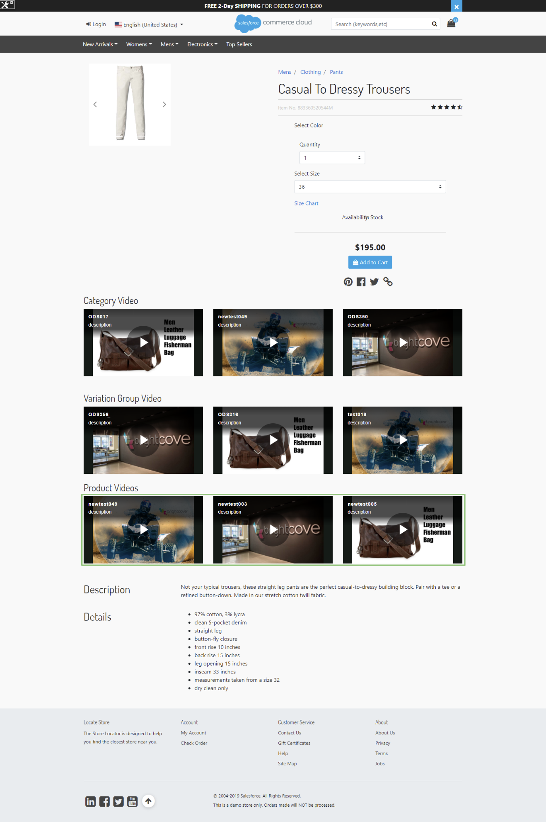

## Product Page – Product Set(setDetails)

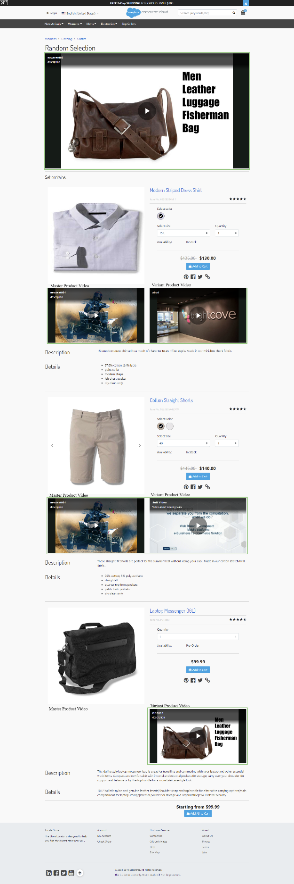

## Product Page – Product Bundle(bundleDetails)

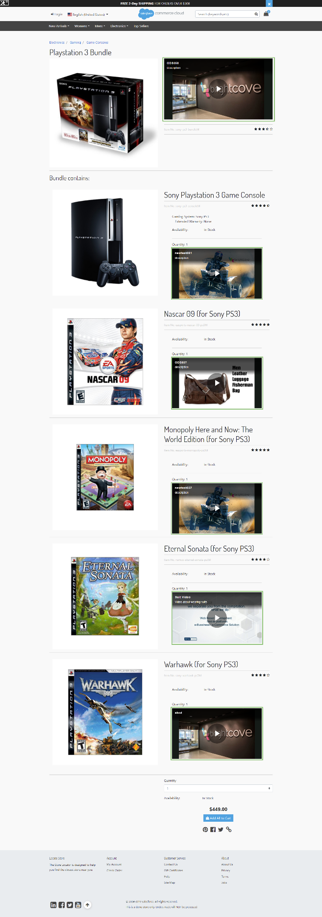

# SiteGenesis Architecture

## Category Page (catlanding, categoryproducthits)

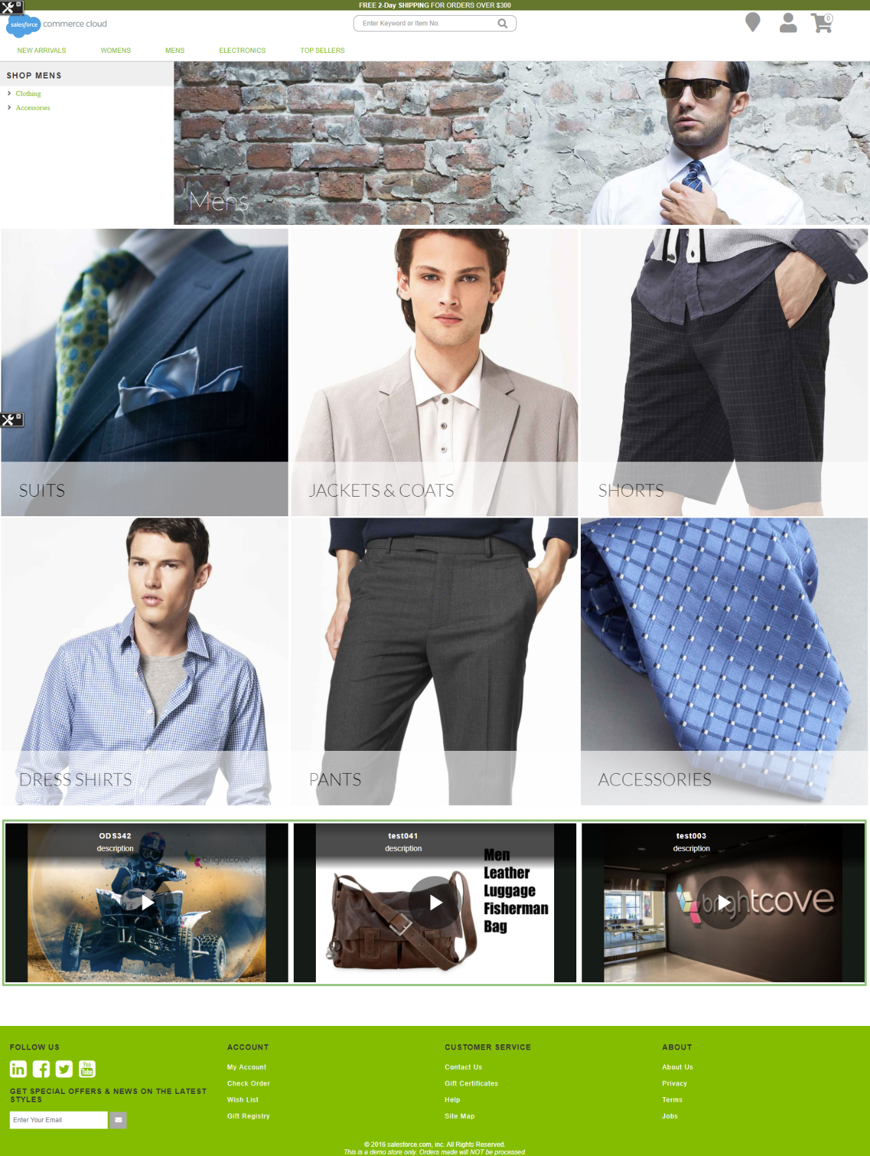

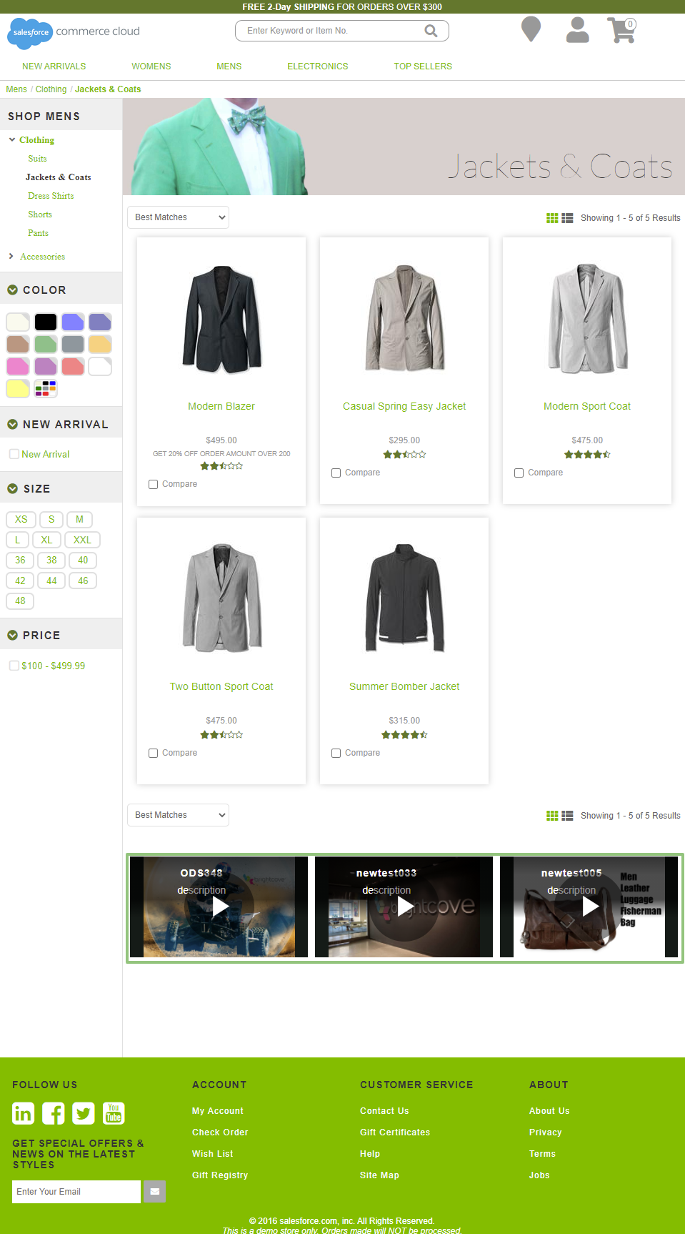

## Product Page - Master/Variant (productcontent, producttopcontent)

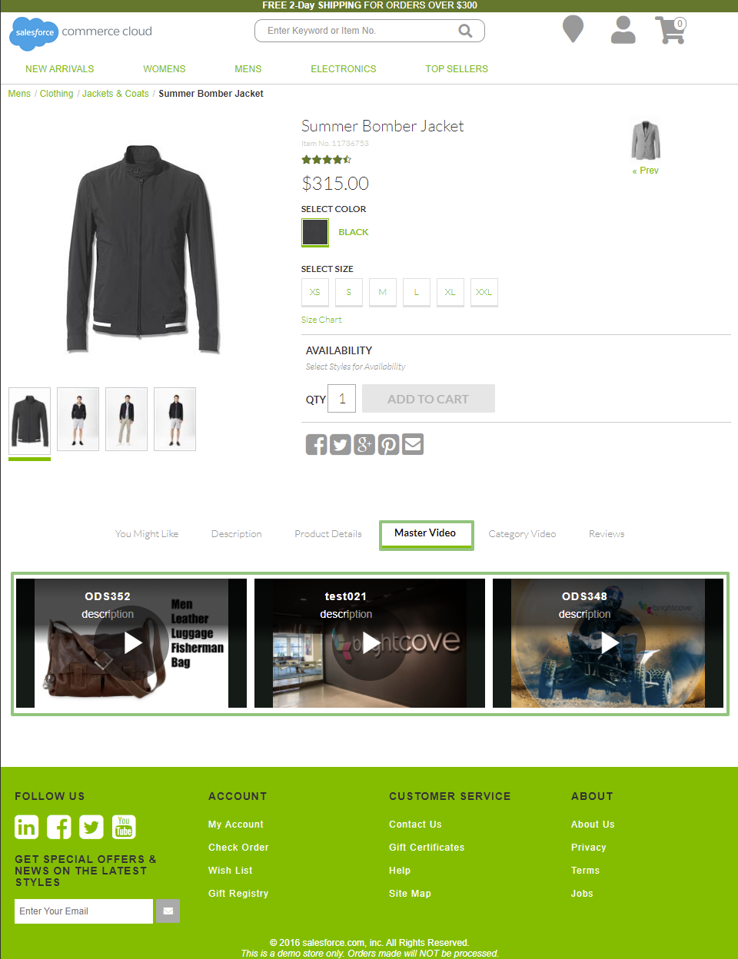

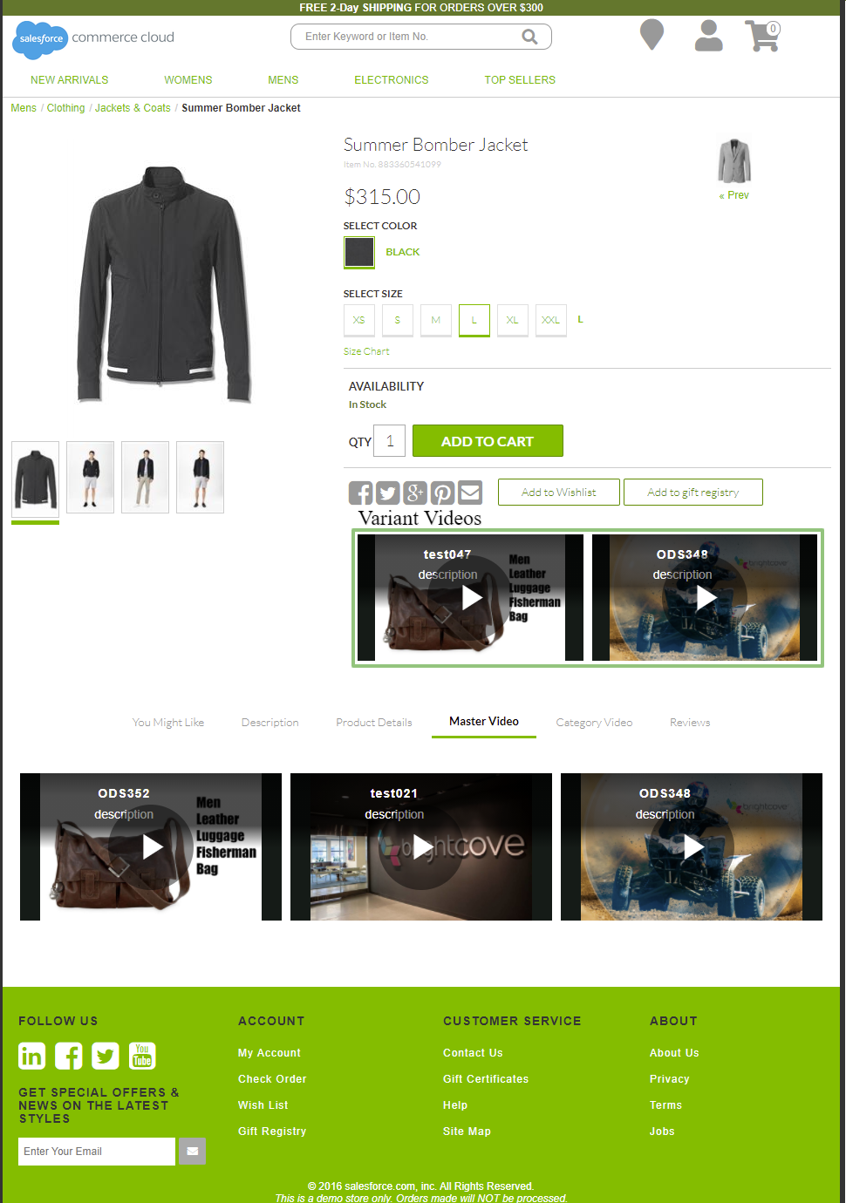

## Product Page - Standard Products (productcontent, producttopcontent)

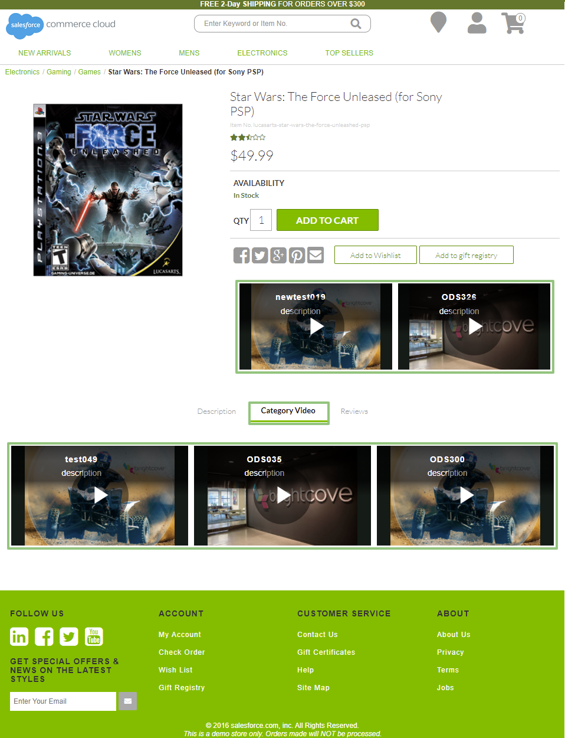

## Product Page - Variation Group (productcontent, producttopcontent)

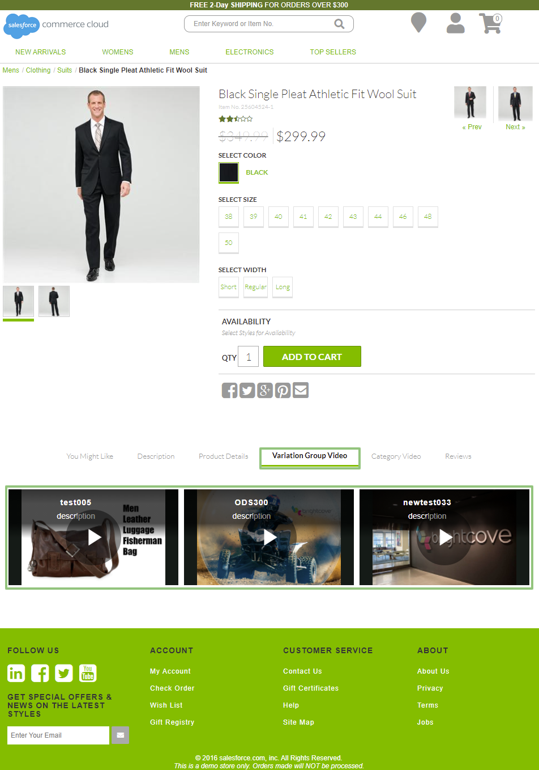

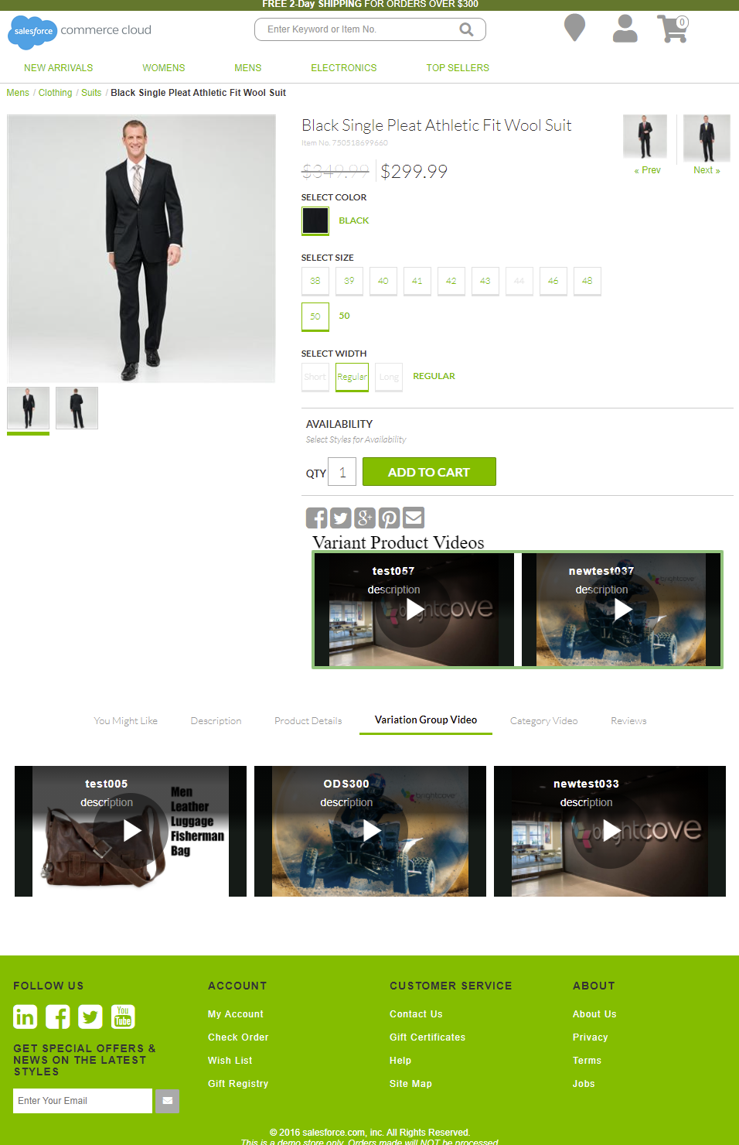

## Product Page – Product Set (producttopcontentPS)

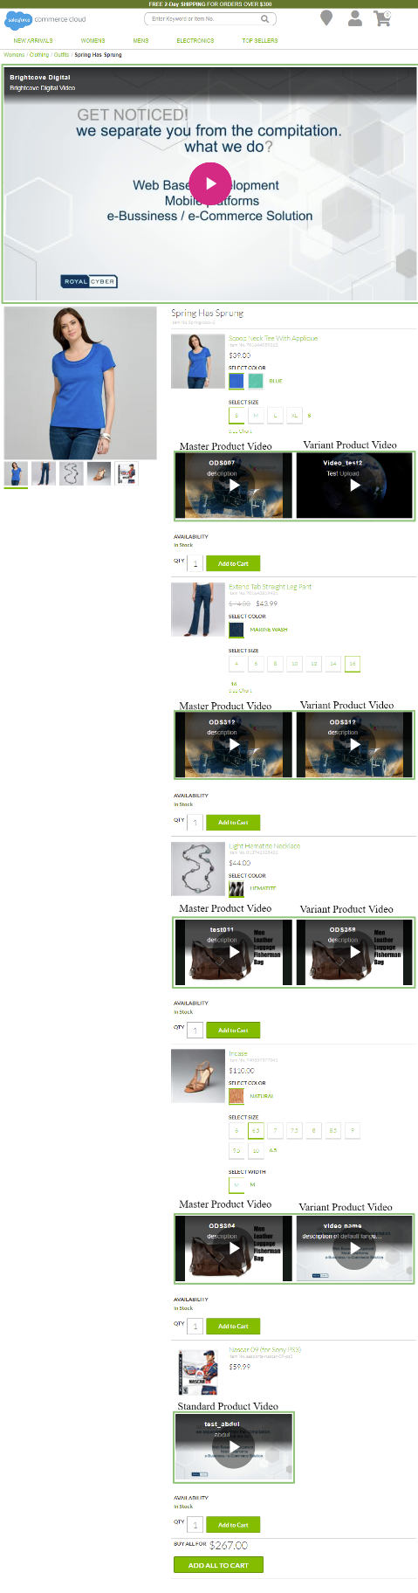

## Product Page – Product Bundle (producttopcontentPS)

